
REPUBLIC OF GHANA

COMPOSITE BUDGET

FOR 2022-2025

PROGRAMME BASED BUDGET ESTIMATES

FOR 2022

ASANTE AKIM CENTRAL MUNICIPAL ASSEMBLY

Table of Contents
PART A: INTRODUCTION 5
1. ESTABLISHMENT OF THE DISTRICT 5
2. POPULATION STRUCTURE 5
3. DISTRICT ECONOMY; 5
a. AGRICULTURE 5
b. MARKET CENTRE 5
c. ROAD NETWORK 6
d. EDUCATION 6
e. HEALTH 7
f. WATER AND SANITATION 7
g. ENERGY 8
4. VISION OF THE DISTRICT ASSEMBLY 8
5. MISSION STATEMENT OF THE DISTRICT ASSEMBLY 8
6. KEY ACHIEVEMENTS………………………………………………………………………….8
7. REVENUE AND EXPENDITURE PERFORMANCE 10
(a) REVENUE PERFORMANCE 10
(b) EXPENDITURE PERFORMANCE 12
PART B: STRATEGIC OVERVIEW 14
1. GSGDA II POLICY OBJECTIVES 14
NMTDF POLICY OBJECTIVE IN LINE WITH SDGs AND TARGETS AND COST 14
GOAL 19
CORE FUNCTIONS 19
2. POLICY OUTCOME INDICATORS AND TARGETS 20
REVENUE MOBILIZATION STRATEGIES FOR KEY REVENUE SOURCES IN 2019 21
PART C: BUDGET PROGRAMME SUMMARY 22
PROGRAMME 1: MANAGEMENT AND ADMINISTRATION 22
SUB-PROGRAMME 1.2 Finance and Revenue Mobilization 26
SUB-PROGRAMME 1.3 Planning, Budgeting and Coordination 29
SUB-PROGRAMME 1.5 Human Resource Management 32
PROGRAMME 2: INFRASTRUCTURE DELIVERY AND MANAGEMENT 34
SUB-PROGRAMME 2.2 Physical and Spatial Planning 38
1. Budget Sub-Programme Objective 41
PROGRAMME 3: SOCIAL SERVICES DELIVERY 44
SUB-PROGRAMME 3:1 Education and Youth Development 46
SUB-PROGRAMME 3.2: Health Delivery 48
SUB-PROGRAMME 3.3: Social Welfare and Community Development 50
PROGRAMME 4: ECONOMIC DEVELOPMENT 53
SUB-PROGRAMME 4.1. Trade, Tourism and Industrial Development 54
SUB-PROGRAMME 4.2: Agricultural Development 58
PROGRAMME 5: ENVIRONMENTAL AND SANITATION MANAGEMENT 61
SUB-PROGRAMME 5.1 Disaster prevention and Management 62

LIST OF TABLES
Table 1 Various Market centers in the Municipality with their respective locations.: 6
Table 2: Key Achievements 9
Table 3: Revenue Performance - IGF 10
Table 4: Expenditure Performance 12
Table 5: Policy Objectives In Line With SDGs and Targets and Cost 14
Table 6: Policy Outcome Indicators and Targets 20
Table 7: Budget Results Statement - Administration 24
Table 8: Main Objectives and Projects 25
Table 9: Budget Results Statement - Finance and Revenue Mobilization 27
Table 10: Main Operations and Projects 27
Table 11: Budget Results Statement – Planning, Budgeting and Coordination 30
Table 12: Main Objectives and Projects 30
Table 13: Budget Results Statement – Human Resource Management 33
Table 14: Main Operations and Projects 33
Table 15: Budget Results Statement – Urban Roads and Transport Services 36
Table 16: Main Objectives and Projects 36
Table 17: Budget Results Statement – Physical and Spatial Planning 39
Table 18: Main Objectives and Projects 40
Table 19: Public Works, Rural Housing, and Water Management 42
Table 20: Main Objectives and Projects 43
Table 21: Budget Results Statement – Education and Youth Development 47
Table 22: Main Operations and Projects 47
Table 23: Budget Results Statement – Health Delivery 49
Table 24: Main Objectives and Projects 49
Table 25: Budget Results Statement – Social Welfare and Community Development 51
Table 26: Main Objectives and Projects 51
Table 27: Budget Results Statement - Trade, Tourism and Industrial Development 56
Table 28: Main Objectives and Projects 56
Table 29: Budget Results Statement – Agricultural Development 59
Table 30: Main Operations and Projects 60
Table 31: Budget Results Statement - Disaster Prevention and Management 63
Table 32: Main Operations and Projects 63

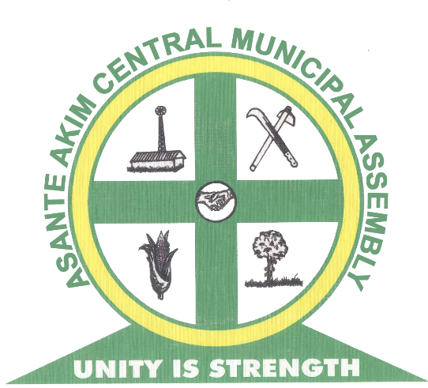

At the general meeting of the Asante Central Municipal Assembly held on 23rd & 24th September, 2021 at the Municipal Assembly Hall at Konongo, approval was given to the 2022 Composite Annual Budget of the Assembly.

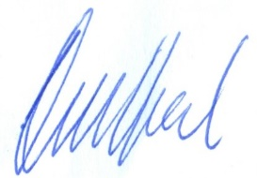
HON. SAMUEL OHEMENG DAVID OWUSU ANSAH
(PRESIDING MEMBER) (MUN. COORDINATING DIRECTOR)
Compensation of Employees Goods and Service Capital Expenditure
GH¢ 3,375,743.00 GH¢4,987,675.00 GH¢4,937,082.00

Total Budget GH¢13,300,500.00

PART A: INTRODUCTION
- ESTABLISHMENT OF THE DISTRICT

The Asante Akim Central Municipal (formerly Asante Akim North Municipal) Assembly is one of the thirty (43) Districts in the Ashanti Region. It was created by Legislative Instrument (L.I) 2056 and it has Konongo – Odumasi as its twin Capital Town. It was carved out of the then Asante Akim District Council in 1988 and was elevated to Municipal status by L.I 1907 in November 2007. Until July 2012, it used to be Asante Akim North Municipal Assembly but with the carving out of the Asante Akim North District, the Municipal Assembly was re-named Asante Akim Central. For the purpose of decentralization and local government representation, the Municipality has one (1) electoral constituency for parliamentary representation, Twenty-five (25) electoral areas for Municipal Assembly representation and three (3) zonal councils (Konongo-Odumasi, Dwease-Praaso and Owereagya councils).
Composition of General Assembly
Composition | Males | Females | Total
Elected Members | 25 | 0 | 25
Appointed Members | 9 | 2 | 11
Total | 34 | 2 | 36
Source: MPCU AACMA, 2020
By law, the Assembly meets at least 3 times a year upon a call to meeting by the Honourable Presiding Member. The Assembly has 8 Sub committees. The table below indicates the composition of the various sub committees of the Assembly.
Composition of the Sub-Committees in the District Assembly
Sub Committee | Males | Females | Total
Justice and security | 7 | 0 | 7
Development planning | 7 | 0 | 7
Finance and Administration | 7 | 0 | 7
Social services | 6 | 1 | 7
Works | 7 | 0 | 7
Education Sub Committee | 6 | 1 | 7
MSE Sub Committee | 7 | 0 | 7
Agric Sub-Committee | 7 | 0 | 7
Source: MPCU AACMA, 2020
The Assembly has a Public Relations and Complaints committee which is chaired by the honourable Presiding Member. This committee sits to resolve problems within and among Assembly members and public officials.

Functions of the Asante Akim Central Municipal Assembly
The municipal assembly derives its functions from the Local Government Act and the Legislative Instrument No. 1418 of 1988. Specifically the functions are indicated as follows:
- To see to the overall development of the Municipality by ensuring the preparation and submission of the following through the Regional Co-ordinating Council:
- Development Plans of the Municipality to the National Development Planning Commission for approval
- The budget of the Municipality of the Ministry of Finance for approval
- Formulate and execute plans, programmes and strategies for the effective mobilization of the resources, necessary for the overall development of the Municipality;
- Promote and support productive activity and social development in the Municipality;
- Initiate programmes for the development of basic infrastructure and provide works and services in the Municipality;
- Responsible for the development, improvement and management of human settlement and environment in the Municipality.

The Municipal Administration
At the Municipal Administration level, the Local Governance Act of 2016, Act 963, mandates thirteen (13) departments of the Assembly that collaborate to provide technical inputs to the general Assembly decisions. The following Departments of the Assembly as prescribed by the LGA Act 963, can be found in the Municipality.
- Central Administration
- Education, Youth & Sports
- Social Welfare and Community Development
- Works (Public Works, Feeder Roads)
- Physical Planning (Town & Country Planning, Parks & Garden)
- Finance
- Natural Resource Conservation (Forestry, Games & Wildlife) *
- Trade & Industry (NBSSI, BAC & Co-operatives)
- Disaster Prevention (NADMO)
- Health (Public Health, Environmental Health)
- Agriculture (Animal Health & Production, Agricultural Extension Services)
- Urban Roads Department
- Transport Department*
These Departments need to be strengthened with staff and the needed logistics for a concentrated development of the entire municipality. Natural Resource Conservation, Forestry, Game and Wildlife Division and the Transport Department are not present in the municipality.
The following Departments and Agencies can also be found in the Municipality
- Information Service Department
- Ghana Revenue Authority
- Social Security and National Insurance Trust
- Internal Audit Department
- Ghana Water Company Limited
- Electricity Company of Ghana
- Ghana Immigration Service
- National Commission on Civic Education
- Ghana Ambulance Service
- Ghana Fire Service
- Valuation Board
- Statistical Service
- National Health Insurance Authority
- National Service Scheme
- Rent Control Department
- Sub-Municipal Structures
The Municipal Assembly has three (3) Zonal Councils, Twenty–five unit Committees within Twenty-Five Electoral Areas and one constituency.
Table 1.23: Number of District Sub structures
NAME | LOCATION
Dwease Praso | Dwease
Konongo-Odumasi | Konongo-Odumasi
Oweriagya | Petriensah
Source: MPCU AACMA, 2021

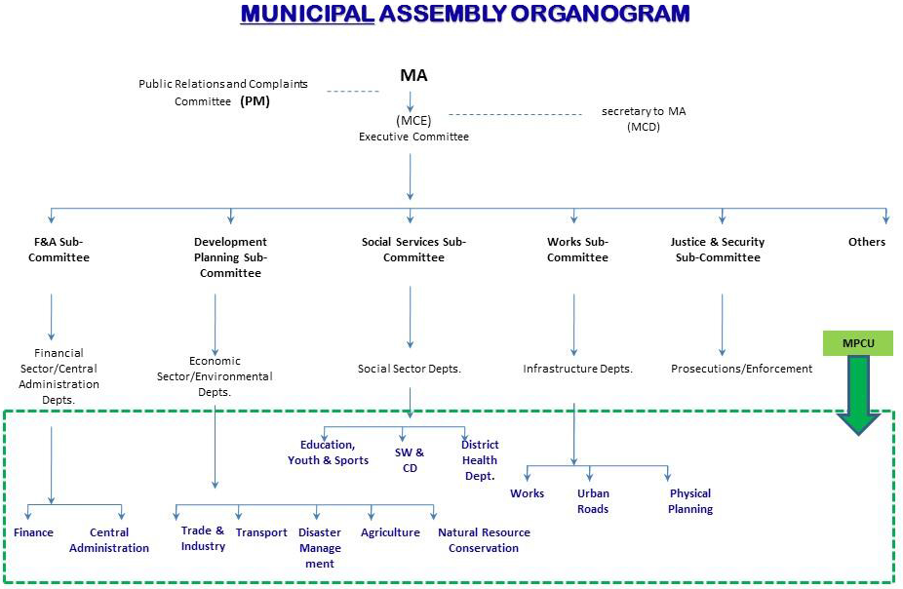

Traditional Authorities
Chieftaincy (the pre-colonial and traditional institution of governance with judicial, legislative, and executive powers) remains an indispensable aspect of the culture of the people in the municipality. This is because the chiefs still remain as custodians of culture. They help in conflict resolution thereby helping keep peace in the municipality. The Chiefs also remain as development partners to the Municipal Assembly.
There are four (4) sub-paramount chiefs, locally referred to as Abrempong, in the municipality. They are the chiefs of Obenimase, Dwease, Kyekyebiase and Petriensa. Petriensa belongs to the Agona clan, Obenimasi is the Oyoko clan, and Kyekyebiase is the Bretuo clan, while Dwease belongs to the Ekona clan.
Odumasi, Konongo and most of the other communities belong to the Juabeng Tradional Council. The chief of Odumasi, for instance, is the Nifahene (Right Wing Leader) to the Juabeng Traditional Stool.
Some age-old traditions are still held onto by the people in the municipality. The people observe sacred days like Akwasidae and Fofie. Akwasidae, is held every six weeks and on such a day libation is poured and sacrifices are made to the gods and ancestors. The Friday preceding 10 days to the Akwasidae is called the Fofie (meaning a ritual Friday).
In the municipality, Tuesdays are generally observed as taboo days where people are forbidden to undertake any farming activities. Such days are used for communal labour to help in the development of the communities.

LOCATION AND SIZE
The Asante Akim Central Municipal Assembly is located in the eastern part of the Ashanti Region. It shares boundaries with Asante Akim North Municipal at the North, Juaben Municipal and Sekyere East at the West, Asante Akim South at the East and South. The land size of the Municipality is 300 square kilometers (km2) forming 1.6 % of the total land area of Ashanti region.
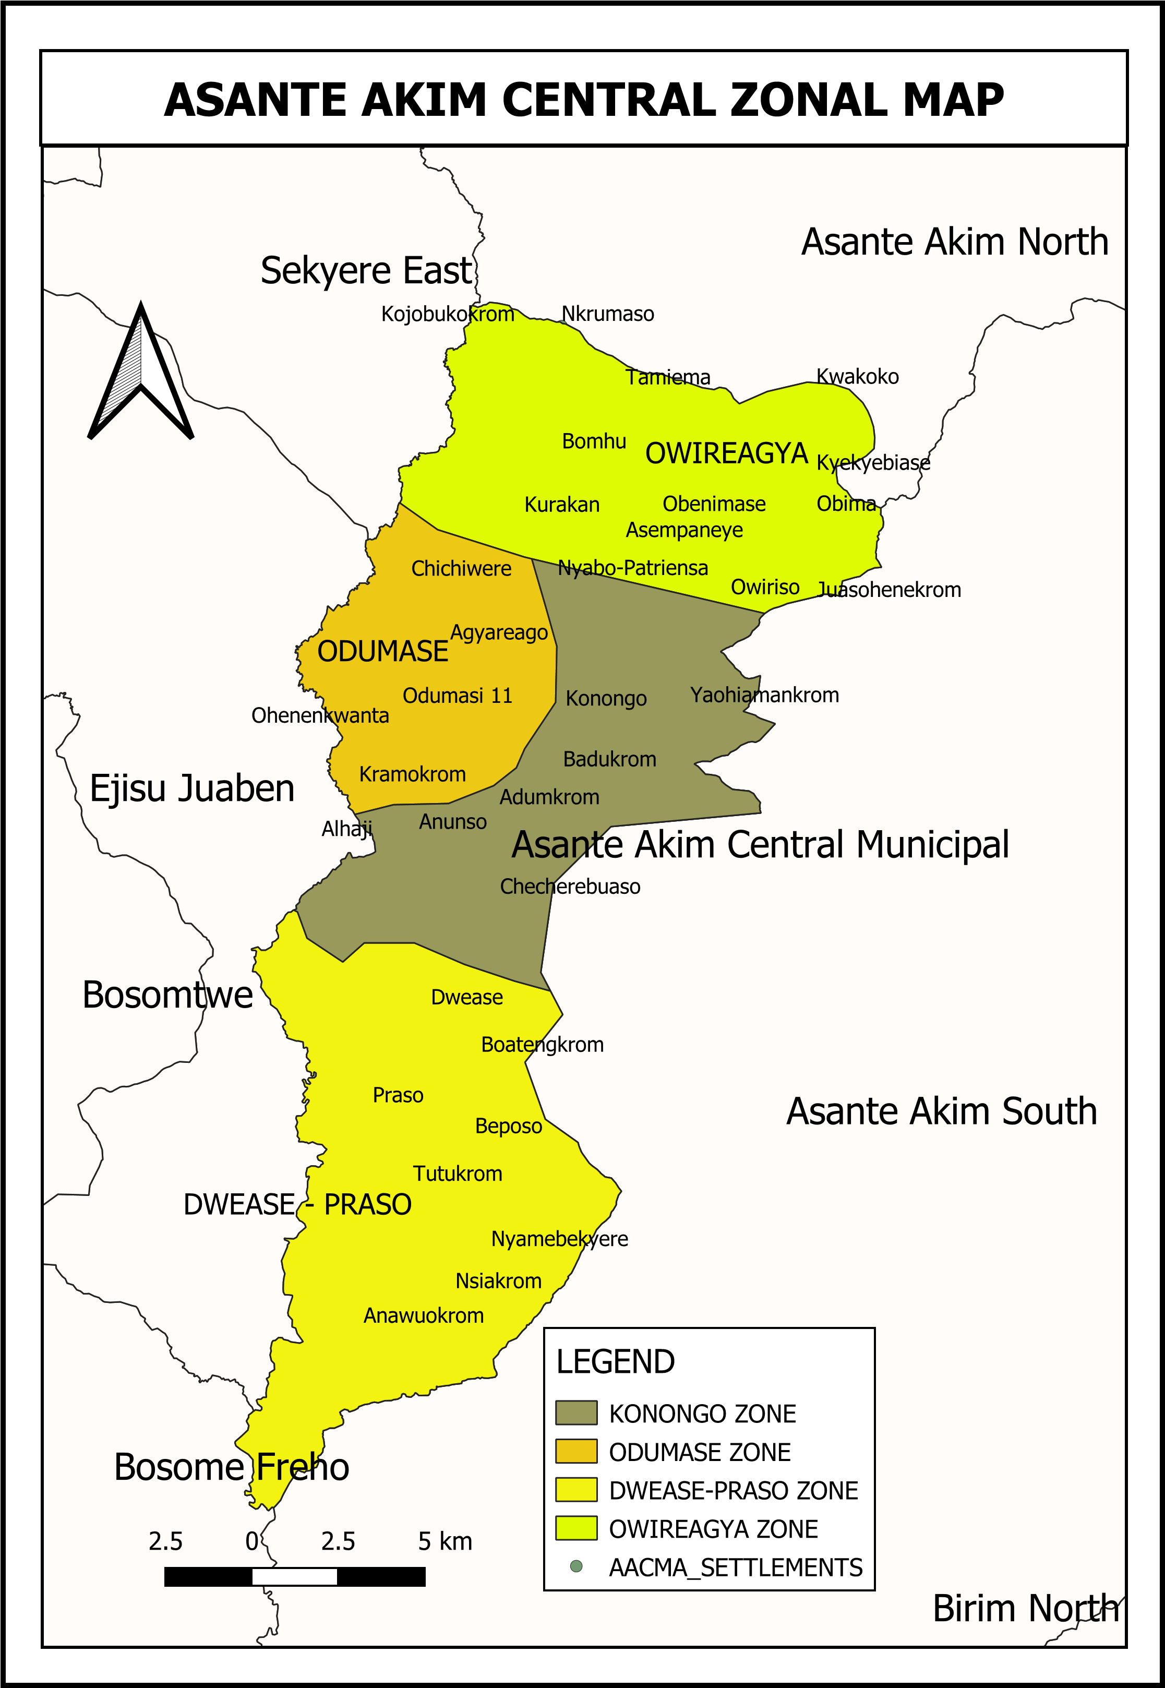

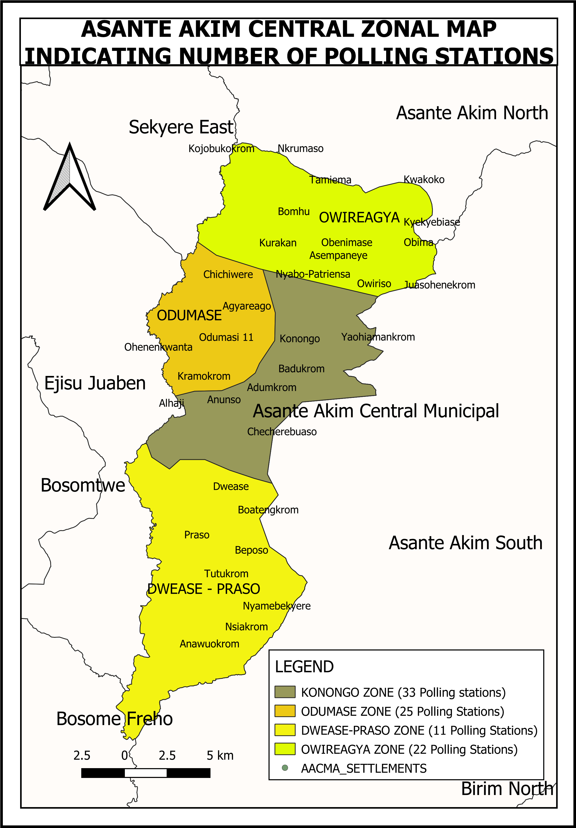
Figure 1: Map of Asante Akim Central Municipal Assembly
- POPULATION STRUCTURE

The population of the Municipality, according to the 2010 Population and Housing Census is 71,508. This comprises of 33,942 males (47.5%) and 37,566 (52.5%) females. With a growth rate of 2.7%, the population of the Municipality for the year 2020 and 2021 is estimated to be 93, 673 and 96,237 respectively.

POPULATION GOWTH AND DISTRIBUTION
The total population of the Municipality is 93,338 (projected from 2010 Population 71,508 with a growth rate of 2.7% per annum) Sex disaggregation of the population in the Municipality follows both the national and regional trends where females out number males. Females represent 52.5 percent of the population against 47.5 percent males.
The population is predominantly urban as most of the people in the municipality are in the Urban settlements (67.8 percent represents Urban and the remaining 32.2 percent represents Rural)
Table 1.4: Trends in Population Growth
YEAR | ASANTE AKIM CENTRAL |  |  | ASHANTI REGION
YEAR | FEMALES | MALES | TOTAL | FEMALES | MALES | TOTAL
2017 | 45,268 | 40,901 | 86,169 | 2,969,557 | 2,790,882 | 5,760,439
2018* | 46,490 | 42,005 | 88,495 | 3,049,735 | 2,866,235 | 5,915,970
2019* | 47,745 | 43,139 | 90,884 | 3,132,078 | 2,943,624 | 6,075,702
2020* | 49,034 | 44,304 | 93,338 | 3,216,644 | 3,023,102 | 6,239,746
2021* | 50,357 | 45,500 | 95,858 | 3,303,493 | 3,104,725 | 6,408,219
2022* | 51,717 | 46,728 | 98,446 | 3,392,687 | 3,188,553 | 6,581,241
Source: Population Census Reports (2010) *Projected, 2022.

Religion
The dominance of Christians in the municipality is profound (83.6%). Fairly represented are the Islam (10.2%) and traditional religions (0.5%). However, there are others who do not belong to any religion (5.4%). Having over 90% of the population being Christians and Moslem can serve as an avenue for promoting developments in the municipality.
Table 1.8: Religious Distribution of Population
Religion | Number | Percentage (%)
No religion | 3,877 | 5.4
Catholic | 8,201 | 11.5
Protestants (Anglican Lutheran etc.) | 16,512 | 23.1
Pentecostal/Charismatic | 21,784 | 30.5
Other Christian | 13,194 | 18.5
Islam | 7,264 | 10.2
Traditionalist | 343 | 0.5
Other | 333 | 0.5
TOTAL | 71,508 | 100
Source: Ghana Statistical Service, 2010 Population and Housing Census
The meeting places of these religions can be used as a tool to sensitize the residents on their roles and responsibilities in promoting development in the municipality.

2 CLIMATE
The Municipality lies within the semi-equatorial belt (areas lying near or at the equator), it experiences double maxima rainfall in a year, that is there are two rainfall peaks received. The first rainy season is from May to July and the second from September to November. Mean annual rainfall ranges between 855mm and 1,500mm. The average number of rainy days for the year is between 110 and 120 days. The dry harmattan season occur between December and April and is associated with drought conditions, high temperatures, and early morning moist/fog and cold weather conditions. Streams dry up during this period. The north-western portion of the municipality has a precipitation of 1300-1400 which receives low amount of rainfall whiles two-thirds (2/3) of the municipality starting from the north- eastern part to the southern part has a precipitation of 1400-1500 which also receives the highest amount of rainfall.
Temperature in the municipality is found to be uniformly high all year round with a mean annual temperature of 26oC, the closer to the equator an area is, the more solar radiation it is exposed to which creates warmer temperature. During the rainy season, humidity is very high, that is when the air has high moisture content. However, the months of December to February, record very low humidity resulting in low moisture content in the atmosphere.
The climatic condition is suitable for the cultivation of cash and food crops such as cocoa, oranges, plantain and vegetables to feed the agro based industries in the Municipality to generate greater income and enhance food security. Again, the relatively high temperatures and sunshine favours the processing of most crops such as cocoa, maize etc. The double rainfall maxima regime of the municipality makes it possible for farmers to cultivate both food and cash crops two times in a year.

Figure 2: Climatic Map of Asante Akim Central Municipal Assembly

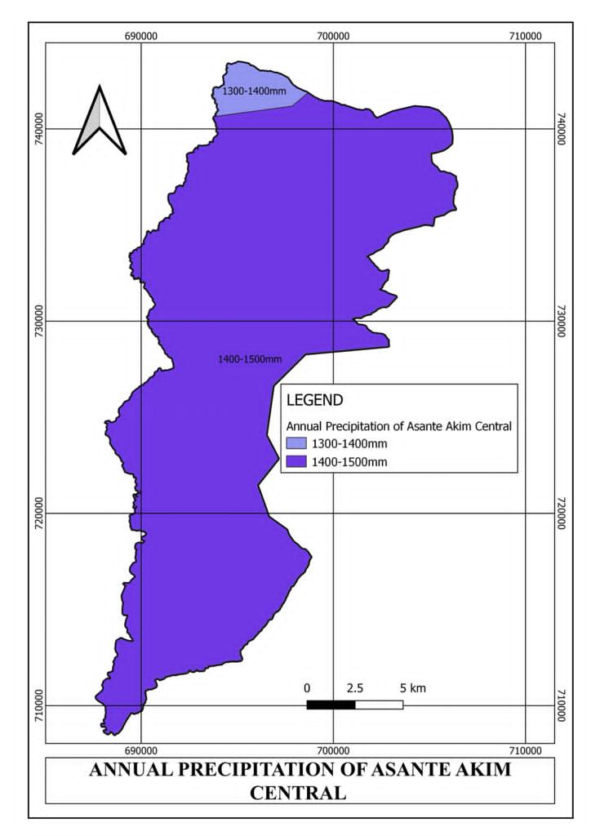

- DISTRICT ECONOMY

a. AGRICULTURE
Agriculture, the mainstay of the local economy, produces food and vegetable crops such as cassava, cereals, tomatoes, and garden eggs. Cash crops such as cocoa, oil palm, and oranges are extensively cultivated in the municipality. With the increasing population, there is likely to be pressure on arable land. The weather is particularly suitable for snail rearing and mushroom farming and these could serve as alternative agricultural livelihoods. Livestock is mainly kept on free range basis with cattle and poultry kept for commercial purposes. Investors also take advantage of the enabling environment in the animal husbandry sector.
Major activities in Agricultural sector are crop farming and livestock production employing about 70% of the active working population. Four types of agricultural activities were defined namely crop farming (66.3%), tree growing (18.4%), livestock rearing (14.8%) and fish farming (0.5%). The highest proportion of farming households are engaged in crop farming (66.3%), while the least proportion of households are into fish farming (0.5%). More than 9 in 10 rural households are engaged in crop farming (66.3%) compared to a slightly lower proportion of urban households (33.7% which are engaged in crop farming and animal rearing and poultry production.

Crop Farming
Majority of the farmers in the Municipal are involved in crop farming and the main crops cultivated are:
- Starchy staples like cassava, cocoyam, and plantain,
- Legumes like cowpea, vegetables like tomatoes, okro, garden eggs, pepper, cabbage and lettuce.
- Tree crops like oil palm, cocoa, citrus.
- Cereals like maize and rice. Both cereals are planted twice during the year, i.e during the major and minor seasons.
- Pineapple cultivation is being perused vigorously in the municipal
The predominant farm practice is mixed cropping. The crops grow in mixed stands normally inter-cropped with vegetable and cultivated for both home consumption and/or sale. However some amount of sole cropping is done in both Maize and Rice.

Types of Livestock and other Animals Reared
Animal rearing is the second most important agricultural activity after crop farming. Most of the farmers engaged in crop farming also keep livestock. The number of animal species kept in the Municipal is 26,824. Out of this number, there are 5,761 keepers and an average of 7 animals per keeper. The average animal per keeper for goat and sheep are 7 and 12 respectively. The types of animals reared are sheep, goats, pigs cattle and poultry. These are reared as supplementary activities to meet part of the protein requirements and to earn additional income. The animals reared are kept in styles pens and hencoops. The goats, sheep and pigs are fed through the pen system and also other farmers who do not have proper structures provides some supplementary feeding. However the free grazing method that is grazing on the open vegetation is also practiced especially Cattle grazing, while the others especially poultry production.
There are only a few known viable fishponds in the Municipal. The main difficulty lies with the cost of construction of ponds, maintenance, feeding and marketing of cat fish which is the predominantly the specie most farmers are into. .

Land Tenure System
Land is acquired in several ways in the Municipal. These include Individual ownership or inheritance from family, Rent or hiring from landowners and the land tenure arrangements include; Owner occupancy- the farmer is the owner of the land on which he/she works and provides all the necessary inputs for production. Share tenancy – This is the “abunu” or the “abusa” share cropping system, where the owners lease the land to the farmer, and the farm produce shared equally (abunu) or a third goes to the tenant, while two-thirds goes to the landlord (abusa).

Marketing System
Urban-based middlemen within and outside the Municipal undertake marketing of farm produce. Most of the farmers sell their produce at the nearest local market to these middlemen who in turn send them to other marketing centers especially the Konongo and Odumase market for sale. The pricing of agricultural produce, which is determined by supply and demand but negotiated by the middlemen, is unfavorable to the farmers. Prices of farm produce are therefore, very low especially when during harvest time when there is a glut and serve as disincentive to the farmers. The poor roads to farming areas have also created for the farmers’ limited access to the bigger markets, which can offer better price for their crops. The Municipal has 1 daily markets and 3 periodic markets that are geographically distributed in the Municipal. Greater volume of trade takes place at Konongo, Odumase and Dwease markets. The biggest of these markets is the Konongo market. The market days are Tuesdays and Fridays. The area of influence of the market includes the Eastern, Brong Ahafo, Ashanti, and Greater Accra Regions. Tomato and Onions also flood the market from the Northern part of the country as well as Burkina Faso. Rice processing in also one major activity in the Municipal attracting marketers from many regions to buy and sell. The main items of trade are agricultural and industrial produce.

Effect of human activity on farmlands and production
Mining activities over the year has wrecked considerable havoc on farmlands by stripping the land of the topsoil and also leaving gaping holes most times filled with water and serving as death traps to unsuspecting people. Agriculture production by itself has also rendered some cultivated areas grassland instead of the usual forest cover. Practices such as inappropriate land preparation and irregular use of fertilizers to sustain growth of cultivated crops have led to a reduction of soil fertility

Irrigation Schemes
There is no major irrigation facility in the Municipal at the moment. However efforts are being made by MOFA to reclaim the abundant irrigation site at Agyareago which has a land area of over 200ha destroyed by illegal mining to promote dry season vegetable farming as well as rice farming. Small-scale farmers on their own ways have been resorting to the use of pumping machines for irrigating their farms especially for dry season farming. The system is also further promoted by MOFA and Tropenbos project to support farmer groups and individuals reclaim degraded lands for farming and also through the department to acquire small pumping machines.

Value Addition and Farmer Based Organizations (FBOs)
Value addition of farm produce in the Municipal is mostly pursued by Farmer Based Organizations who are engaged in widespread processing of oil palm, kernel oil and Cassava and Rice. Other FBOs are also engaged in marketing and production of food and cash crops like rice and cocoa respectively. Development partners working in the district such as the Hunger Project, Child Aid and Youth Development Network augment the efforts of the Municipal Agriculture Development Unit by building the capacity of women and Farmer Based Groups in Gari processing, and palm oil processing and soap making and showel gel. The table below shows the 15 recognized Farmer Based Groups in the Municipal, their location and area of operation. The capacities of the FBOs have been built to enhance value chain of the various food crops and also serve as input suppliers to farmers. The FBOs can be linked to financial institutions by registering them into cooperatives.
Table 1.19: FBOs in the Municipal
Type of FBO | Number | Location
Oil Processing and marketers | 1 | Agyerago Shito Village
Cassava and Cocoa producers | 1 | Obeniamse Kwayem,Nyaboo,
Maize and Cocoa Producers | 2 | Happy Brothers Kwayem
Bee Keeping and Marketing | 1 | Adumkrom
Crop producers | 4 | Konongo, Patriansa Kwayem, Obeniamse, Boatengkrom
Rice Processors | 1 | Bimma
Rice Producer | 5 | Ohene Nkwanta,Dwease, Praaso,
Source: AACMA MADU, 2020

Extension Services
The main aim of the Extension Service in the Municipal is to address the felt needs of the farmers and also to assist them to increase agricultural production through the transfer of improved production and post-production technologies that would support better living standards. This is normally done through home and farm visits, fora, sensitization, farmer training, Research Extension Farmer Linkage through municipal planning sessions at both Zonal and Municipal levels, seminars and demonstrations. More than 85% of farmers have access to extension services.
Each sub-district is manned by a Municipal Development Officer (MDO). The sub-districts are also divided into operational areas, which are also manned by Agriculture Extension Agents (AEAs). Under this scheme, the AEA farmer ratio is 1:2500 There is no private establishments and non-governmental organizations in the municipal that provide some form of extension services to farmers through technical support and provision of credit facilities, seedlings supplies.
Beside Extension Services there are also the following department in the Municipal that support farmers. These are Plant Protection and Regulatory Services, Crop Production Unit ,Animal Production Unit, MIS Unit Women In Agriculture Unit and the Veterinary Services unit that perform various functions to help farmers in the Municipality.

Challenges/problems of the Agriculture Sector
The sector is beset with a myriad of developmental challenges that require strategic planning and concerted efforts to address them. These challenges include but not limited to the following:

- Low agricultural production
- Low level of technology
- Inadequate use of agricultural extension services
- Aged farmers
- Shortage and high cost of labor
- High cost of farm inputs and untimely delivery
- Limited credit facilities
- Frequent land disputes
- Poor marketing network and facilities
- Low prices of farm produce
- Unpredictable nature of the rainfall pattern
- Lack of warehouse for block farm inputs
In summary agriculture in the Municipal is brisk and both farmers and staff as well as the Municipal Assembly are doing all they could to ensure food security ,reduce post-harvest losses ,strengthen the agriculture to better the living standards of the people.

b. MARKET CENTRE

There are six (6) market centres across the municipality. The most vibrant of these markets is the Konongo market with Tuesday as it main market day and Friday as a supportive market day. Due to the nodal position of the market, traders from the neighbouring districts and beyond patronize.

The most vibrant of these market is the Konongo market with Tuesday as it main market day and Friday as a supportive market day.
The table below depicts various market centres in the Municipality with their respective locations.
NB. The table is arranged in order of it vibrancy with the most vibrant market on top.
Various Market centers in the Municipality with their respective locations.
 | NAME | LOCATION | MARKET DAYS
1 | Konongo Market | Konongo | Tuesdays/Fridays
2 | Odumasi Market | Odumasi | Thursdays
3 | Dwease Market | Dwease | Wednesday
4 | Praaso Market | Praaso | Tuesdays
5 | Patriensa Market | Patriensa | Daily market
6 | Odumasi Zongo Market | Odumasi | Daily

c. ROAD NETWORK
The Municipality located along the Accra- Kumasi highway currently has about 10km of asphalted Class I roads, 29km of Class II, and about 327km of Class III. However, feeder roads form a greater percentage of the road network. Some of the feeder roads can be used throughout the year (all season), while others are only accessible on a seasonal basis. The bitumen surface of feeder roads is about 21.2% and that of gravel and earth is 39.2 percent and 50.1 percent respectively. About 19.3 percent of the roads condition is good whilst 18% is fairly good. Overall, more than 72.6%) of the road condition is very poor.
Table 1.11: List of roads in the municipality

S/N | NAME OF ROAD | TYPE | LENGTH (KM)
1 | Konongo-Dwease Praaso | Arterial | 25
2 | Konongo-Stadium Road | Collector | 3
3 | Konongo Low Cost-Ssnit Road | Collector | 5
4 | Sarpomaa Jct-Blue Moon | Collector | 5
5 | Ekoso-Freetown Road | Collector | 6
6 | New Hospital Road | Collector | 4
7 | Odumasi-Ohene Nkwanta Road | Collector | 4
8 | Konongo-Zongo Road | Collector
9 | Abosomtweagya Town Road | Collector | 7
10 | Ahyiaem North Area Roads | Collector | 7
11 | Ahyiaem South Area Roads | Collector | 3
12 | Blue Moon Area Roads | Collector | 7
13 | Freetown Area Roads | Collector | 4
14 | Ekoso Area Roads | Collector | 10
15 | Odumasi Town Roads | Collector | 6
16 | Akrantiebesa Area Roads | Collector | 8
17 | Residency Area Roads | Collector | 5
18 | Nsiakrom Jct-Nsiakrom | Feeder | 8.5
19 | Agyareago-Kyekyewere | Feeder | 1.8
20 | Beposo Jct-Beposo | Feeder | 1.55
21 | Tutukrom Jct-Nsiakrom | Feeder | 5.35
22 | Dwease-Boatengkrom Jct | Feeder | 3.95
23 | Kwakoko Jct(Kyekyebiase) - Kwakoko Jct | Feeder | 1.8
24 | Adofo Asiama-Atunsu | Feeder | 1.4
25 | Odumasi-Gwsc | Feeder | 5.6
26 | Adumkrom Jct-Alhaji | Feeder | 10.5
27 | Konongo-Dickson | Feeder | 25
28 | Boatengkrom Jct-Boatengkrom | Feeder | 0.9
29 | Patriensa-Ohemengkrom | Feeder | 10
30 | Agyareago-Annuruso | Feeder | 13.5
31 | Atunsu-Annuruso | Feeder | 11.8
32 | Boatengkrom - Beposo Jct | Feeder | 1.6
33 | Obenemase JCT-Obenemase | Feeder | 1.4

d. EDUCATION
Education in the Municipality is handled by the Municipal Directorate of Education whose responsibility is the administration, monitoring and supervision of teaching and learning in the municipality. The municipality currently has both basic and secondary level Schools. In all there are 89 Pre-Schools, 89 Primary Schools, 66 Junior High Schools, 5 Senior High School and 1 Technical/vocational level.

Table 1.14 above shows the ownership and various levels of educational institutions in the Municipality
LEVEL | PUBLIC SCHOOL |  | PRIVATE SCHOOL |  | TOTAL
LEVEL | NUMBER | % | NUMBER | % | NUMBER | %
KG | 51 | 33.7 | 51 | 40.2 | 102 | 36.7
PRIMARY | 51 | 33.7 | 46 | 36.2 | 97 | 34.9
JUNIOR SENIOR SCHOOL | 46 | 30.5 | 27 | 21.3 | 73 | 26.3
SENIOR HIGH SCHOOL | 3 | 2.1 | 3 | 2.3 | 6 | 2.1
TOTAL | 151 |  | 127 |  | 278
Source: G.E.S AACMA (2020)
The number of educational institutions in Municipality is 278 out of which 151 (54.3%) are public schools while 127 representing 45.7 percent are private schools. For all the levels of education, more than 80 percent are publicly owned, except for Technical and Vocational institutions which are 100 percent owned and managed by private individuals. Kindergarten level is the highest with 102 facilities, followed by primary with 97 facilities. Figure 8 shows the map of educational facilities in the Municipal

Indicators  Level of Education | Gross Enrolment Rate | Net Enrolment Rate | Gender Parity Index | Pupil-Teacher Ratio
KG | 135.2  % | 89% | 1:1 | 24:1
Primary | 123.2% | 78% | 1:1 | 22:1
JHS | 103.7% | 11.7% | 1:1 | 21:1
SHS | 124% | 54% | 1:4 | 23:1
Source: EMIS GES AACMA, 2020.
The following are a summary of trends for the period 2020
- Total number of education facilities in the Municipality has increased
- Enrollment has risen at both basic and secondary levels due in part to the capitation grant policy of the National Government
- The gender parity index (male gross enrollment rate versus female gross enrollment rate) in Kindergarten, Primary, and Junior Secondary schools has fluctuated between the years but is near 1.
- Total number of teachers working at Kindergarten, Primary, and Junior High schools has not kept pace with the increase in enrolment as the pupil to teacher ratio has risen each year.
Key issues or challenges /problems
- Inadequate educational infrastructure
- Inadequate teaching and non-teaching staff
- High school dropout rate at JHS
- Inadequate furniture for schools
- Inadequate teaching and learning materials

e. HEALTH
The Municipal Health Directorate exists to ensure prevention of diseases and avoidable deaths being kept at the barest minimum and everybody in the Municipality has access to quality driven, results oriented, close to client and affordable health service by a well-motivated workforce.
The municipality has 16 operational health facilities, out of which 11 public institution comprising 5 CHPS Compounds, 5 health centers, 4 private clinics, 1 private Hospital and a Government Hospital located at Konongo. Good health condition empowers the working population thereby increasing productivity.

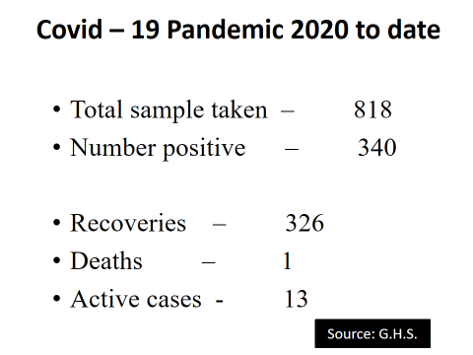

Table 1.16: Distribution of Health Facilities by Sub Municipals
SUB MUNICIPALS | HOSPITAL | HEALTH CENTRE | CLINIC | CHPS COMPOUND | TOTAL
KONONGO | 2 | 0 | 3 | 1 | 16
DWEASE PRAASO | 0 | 2 | 0 | 2 | 4
PATRIENSA | 0 | 2 | 0 | 2 | 4
ODUMASE | 0 | 1 | 1 | 0 | 2
TOTAL | 2 | 5 | 4 | 5 | 16

Tables below present recorded indicators and achievement using 2018 as a base year,
Objective
1: Ensure Sustainable, Affordable, Equitable, Easily Accessible Healthcare Services (Universal Health Coverage)
Maternal health
Indicators | Years |  |  | Target | Score
Indicators | 2018 | 2019 | 2020 | Target | Score
Family planning Acceptor rate (SDG) | 19.3 | 20.2 | 21.8 | 40% | 1
Total estimated protection by contraceptive methods supplied (Couple Year Protection (CYP)) | 563,4 | 3,958 | 3,534 | 10,147 | -2
Proportion of deliveries attended by trained health workers (SDG | 71.3 | 69.1 | 69.3 | 60 | 2
Proportion of mothers receiving postnatal care (PNC) within 48 hours from birth | 85.0 | 96.6 | 99.1 | 80% | 2
Percentage of babies breastfeeding within 30minutes after delivery* | 96.3 | 93.8 | 91.0 | 95

Indicators | Years |  |  | Target | Score
Indicators | 2018 | 2019 | 2020 | Target | Score
Proportion of mothers who made at least four ANC visits | 95.2 | 77.4 | 74.5 | 78%
The proportion of children due for Measles-Rubella 2 receiving LLIN* | 85.0 | 74.0 | 95.0 | 85 | 2
Doctor to population ratio (SDG) | 1:14,207 | 1:17,508 | 1:14876 | 1:7500
Nurse to population ratio (SDG) | 1:1065 | 1:540 | 1: | 1:450
Midwife to Women in Fertility Age (WIFA) population ratio. (SDG) | 1:584 | 1:2036 |  | 1:700

Years

Indicators | Years | Target |  |  | score
Indicators | 2018 | 2019 |  | 2020
Proportion of outpatient who are insured* | 92.0 | 89.8 |  | 87.8 | 82.0%
Midwife to WIFA population geographical equity index | 0.07 | 0.14 |  |  | 0.55
Doctor population geographical equity index | 0.2 | 0.2 |  |  | 0.2
Nurse population geographical equity index | 0.07 | 0.11 |  |  | 0.55
Proportion of functional Community Health Planning and Services (CHPS) zones | 100 | 100 |  | 100 | 80 | 2
Indicators | Years |  |  |  | Target | Score
Indicators | 2018 |  | 2019 | 2020 | Target | Score
Skilled delivery geographical equity index | 0.18 |  | 0.01 | 0.01 | 0.70 | -1
Per capita Outpatient Department (OPD) attendance | 1.3 |  | 0.88 | 0.81 | 1 | -1
Percentage of Districts with at least one functional vehicle less than five years old* | 0 |  | 100 | 100 | 80 | 2
Health facility density*(SDG) distribution of facilities per 10,000 population | 1.76 |  | 1.72 | 1.69 | 15 | -1

Top 10 Causes of Admissions 2020-asc

Top 10 Causes of DEATH 2020- ASC

Objective 2: Reduce Morbidity and Mortality, Intensify Prevention and Control of Non-Communicable Disease
Indicators | Year |  |  | Target | Score
Indicators | 2018 | 2019 | 2020 | Target | Score
Proportion of facility deaths that are medically certified* | 0 | 86 | 103 | 80% | 2
Incidence rate of of Diabetes (OPD as proxy) | 0.80 | 0.29 | 0.37 | 1-5% | 1
Incidence rate of Hypertension (using OPD as proxy) * (SDG) | 2.7 | 0.70 | 1.10 | 5-10% | 1
Proportion of children U5 who were measured to assess stunting* (SDG proxy) | 0.12 | 5.59 | 14.55 | 10% | 2
Prevalence of anaemia in pregnant women at 36 weeks of gestation* | 36.2 | 30.3 | 46.4 | 25% | -2

Indicators | Years |  |  | Target | Score
Indicators | 2018 | 2019 | 2020 | Target | Score
Children under five years who are underweight*(SDG) | 2.4 | 5.4 | 5.5 | 3% | -2
Institutional all-cause mortality rate | 8.7 | 14.2 | 13.7 | 18 | 2
Institutional Maternal Mortality Ratio per 100,000(proxy SDG) | 41.8 | 41.4 | 0 | 125 | 2
Institutional Neonatal Mortality Rate per 1000 (proxy SDG) | 1.3 | 1.7 | 0.4 | 8 | 2
Still birth rate | 16.4 | 12.3 | 5.6 | 12 | 2

Some maternal indicators breakdown
Indicator | 2018 | 2019 | 2020
Indicator | Years
Number of mothers, all deliveries | 2 430 | 2 413 | 2481
Total number of babies, all deliveries | 2 478 | 2 454 | 2522
Live births | 2 395 | 2 415 | 2485
Total Still Birth | 40 | 30 | 14
Fresh still births | 12 | 7 | 4
Macerated still births | 28 | 23 | 10
Total Neonatal Death | 3 | 4 | 2
Total maternal deaths | 1 | 1 | 0

Indicators | Years |  |  | Target | Score
Indicators | 2018 | 2019 | 2020 | Target | Score
Percentage of maternal deaths that are audited | 100 | 100 | 100 | 90 | 2
Adolescent mortality rate per 10,000* | 1.05 | 1.5 | 1.5 | 1.8 | 2
Proportion of Total Mortality attributed to unsafe water, unsafe sanitation and lack of hygiene (Cholera, Typhoid fever and Paratyphoid) * (SDG) | 0 | 0 | 0 | 0.5% | 2
Proportion of Total Mortality attributed to external cause (Road accidents, falls,burns, accidental poisoning and exposure to noxious substance, accidental drowning other transport accident | 0 | 0 | 1.59 | 5-10 | 1
Proportion of total mortality attributed to non-communicable diseases (Neoplasm, Circulatory and cardiac conditions, Diabetes, Chronic Obstructive respiratory diseases) * (SDG) | 18 | 38.9 | 31.7 | 30-50% | 2

Objective 3: Enhance Efficiency in Governance and Management
Indicators | Years |  |  | Target | score
Indicators | 2018 | 2019 | 2020 | Target | score
Proportion of Hospitals (public) with mental health units | 50 | 50 | 50 | 100
Data completeness for WASH/IPC reporting form* | 100 | 100 | 100 | 70% | 2
Proportion of planned Integrated Districts supervisory visits undertaken | 75 | 75 | 50 | 100%
Percentage of planned Data validation meetings held * | 33 | 58 | 50 | 100%
Proportion of health facilities (public and private) providing data in the DHIMS2* | 100 | 100 | 87.5 | 85 | 2

Indicators |  |  |  |  | Target |  | Score
Indicators | 2018 | 2019 | 2020
Completeness of reporting by health facilities | 85 | 85 | 93 | 96
Hospital beds per 1000 population* | 0.5 | 0.5 | 0.51 | 1/1000 |  | -1
Average length of stay at the accident and emergency (A&E) ward of the Hospital* | 2.4 | 1.9 | 1.49 | 2 |  | -1
Percentage Bed occupancy rate for the Hospitals* | 55.0 | 62.6 | 56.8 | 70% |  | -1
Proportion of hospitals (public) with functional emergency department | 100 | 100 | 100 | 100 |  | 2

Indicators | Year |  |  | Target | score
Indicators | 2018 | 2019 | 2020 | Target | score
Percentage of District Hospitals with Functional Public Health Units | 100 | 100 | 100 | 100 | 2
Per capita GoG allocation to health in cedis (Receipts)* | 0 | 0 | 0 | 37

Key Challenges during Year under Review
- Lack of funds / Fuel for the directorate
- Inadequate motorbikes
- Delayed Reimbursement of NHIS Funds
- None use of IFA by pregnant mothers
- Double counting of Hypertensive cases
- Malnutrition among children under 5
- Poor documentation of reports
- Non submission of dhims data by some zones and health facilities
- Non adherence to some malaria interventions
- Inadequate Capacity building for Staffs
- Inadequate Computers for data management
- Inadequate office space/ furniture

NATIONAL FIRE SERVICE
The national fire service exists to provide efficient management and prevention of undefined fires to ensure public safety. The Fire station in Konongo is resourced with equipment, including two (2) fire tenders to help in the fight against fires in the municipality and surrounding districts.

NATIONAL AMBULANCE SERVICES
The national ambulance service was established in the municipality in 2006. The unit operates from one office room in the national fire service office building.
Staff strength of the Konongo Ambulance Service
Category | Male | Female | Total
P/SR/A EMT | 0 | 0 | 0
P EMT B4 | 1 | 0 | 1
S EMT B5 | 0 | 1 | 1
S EMT-B6 | 2 | 1 | 3
EMT B8 | 0 | 0 | 0
EMT B9 | 0 | 1 | 1
Source: AACMA AMBULANCE UNIT, 2021

f. WATER AND SANITATION
The main source of water for domestic and commercial uses is borehole and pipe borne water. Majority of the rural household depends on borehole water for drinking, cooking and other household chores
According to the 2010 PHC District Analytical Report, about forty-seven percent (47%) of the rural household depends on borehole water for drinking, cooking and other household chores.

Other sources include rain water, dug well, rivers, streams etc.

According to 2010 Population and Housing Census, the toilet facility mostly used by household in the municipality is public toilet, (WC, KVIP Pit).

This constitutes 34.2% of the toilet facility. However, appreciable number of the population in the municipality have toilet facilities in their homes. KVIP, Pit latrine and Water Closets constitute 25.7%, 20.7% and 11.2% of the toilet facilities in the municipality respectively. Open defecation and other also constitute 7.6%.

Also, waste management is another sanitation issue confronting the municipality. The commonest method of waste disposal are open space and public containers. Whereas open space is predominantly practiced in the rural areas, public containers is practiced in the urban areas. Other form of waste disposal includes open burning, indiscriminate dumping and refuse pit.

Also, waste management is another sanitation issue confronting the municipality. The commonest methods of waste disposal are open space and public containers. Whereas open space is predominantly practiced in the rural areas, public containers is practiced in the urban areas. Other forms of waste disposal include open burning, indiscriminate dumping and refuse pit

Solid Waste Management
The collection, transportation and disposal of solid and liquid waste are the sole responsibility of the Municipal Assembly which operates through the Zoomlion Company limited. Solid waste is done in three ways: door to door, dumping at refuse site and communal container system. Door to door services is usually provided to middle class in communities such as Konongo, Odumase, Patriensa and Dwease-Praaso. The Municipal Assembly uses 101 waste bins and refuse containers. The most of the Communal Containers are however in bad condition. The Municipal Environmental Health unit in collaboration with Zoomlion regularly administered refuse collection for onward disposal from markets, lorry parks and other public centers. The Municipality has one (1) Final Disposal site as Bomireso.
Notwithstanding this development, most of the refuse dumps have developed into severe eye-sore monuments partly due to the act of crude dumping. Frequent breakdown of the already ill-provided wheel barrow as well as lack of cesspit emptier are compounding the problem.
Solid waste facilities
Type of facility | Number | Required | Condition
Skipper | 2 | 0 | Good
Waste Bins | 80 | 150 | Good
Communal Container | 21 | 10 | Bad
Spraying Machine | 3 | 5 | Good
Total | 106 | 165

Liquid Waste Disposal
The various methods by which liquid waste is disposed by households in the Municipality is presented in Table 1.12. The majority of households (36.6%) in the Municipality dispose liquid waste by throwing onto the street/outside. This is closely followed by throwing onto compound (35.7%). Throwing into gutter has a proportion of 17.3 percent and disposal through drainage into a pit (soak away) has the least proportion (1.3%).
In urban localities, the majority (36.2%) of households dispose liquid waste by throwing onto the street/outside. Throwing onto compound is used by 31.6 percent of households and a little over twenty percent (21.2%) of households dispose liquid by throwing into gutter. Disposal through drainage into a pit (soak away) has the least proportion (1.0%).
For the rural localities, 45.4 percent of households throw liquid waste onto compound. This is higher than the proportion for urban localities (31.6%). About thirty eight percent (37.5%) of households in rural localities throw liquid waste onto the street/outside. This is more than the urban proportion (36.2%) albeit the small margin. Disposing liquid waste through the sewerage system is not common in the rural localities at all, as it has a proportion less than one percent (0.5%).
Method of Liquid Waste Disposal by Households
 | Municipality
 | Total
 | Number | Percent
Total | 16,919 | 100.0
Through the sewerage system | 262 | 1.5
Through drainage system into a gutter | 1,250 | 7.4
Through drainage into a pit (soak away) | 225 | 1.3
Thrown onto the street/outside | 6,187 | 36.6
Thrown into gutter | 2,925 | 17.3
Thrown onto compound | 6,042 | 35.7
Other | 28 | 0.2
Source: Ghana Statistical Service, 2010 Population and Housing Census.

Items in the Unit
The unit currently has a Benz ambulance equipped with the following items
- Oxygen Cylinder
- Trolley
- Spine board
- Scoop board
- Humidifier
- Fetal monitor
- Vitals monitor
- Suction machine
- Glucometer
- Splint
- Bag valve mask (BVM)
- Oro pharyngeal airway
- Nasopharyngeal airway
- Cervical collar
- Oxygen delivery tube
- Thermometer
- ECG
- AED
- Wheel chair
- Sphygmomanometer
- Nebulizer
The period 2018-2020 saw the unit providing the emergency services to the following illnesses
Type | 2018 | 2019 | 2020 | Total
Trauma | 0 | 0 | 3 | 3
Medical | 0 | 0 | 21 | 21
Obs/gynae | 0 | 0 | 29 | 29
Pediatrics | 0 | 0 | 6 | 6
RTA | 0 | 0 | 58 | 58
Missed / Mid Trips | 0 | 0 | 5 | 5
Total | 0 | 0 | 122 | 122
Source: AACMA AMBULANCE UNIT, 2021

g. ENERGY
Energy plays a significant role in households’ day-to-day activities. The main source of energy in the municipality is electricity which is taped from the national grid. It is used for powering domestic appliances for cooking, storage and entertainment, lighting systems among others. According to the 2010 Population and Housing Census (71.5%) have access to electricity in their homes, while 10.4% depend on kerosene lamps. Furthermore, 16.7% of the residents rely on battery-powered flashlights and touches with 0.4% depending on diesel powered generators.
Despite several interventions by government and non-governmental organizations to protect our forests and reduce pollution, majority of residents in the Asante Akim Central Municipality, continue to use firewood. According to 2010 Population and Housing Census, 38.7% of the residents use firewood for cooking while 36.1% use charcoal. Nevertheless, an appreciable number of residents rely on efficient energy sources such as gas (15.6%), electricity (0.3%) and kerosene (0.4%).

MINING AND QUARRYING
The Municipality’s gold deposits have made it one of the notable gold mining areas in the region. Large scale gold mining is done by one company with its main mining site at Konongo with another site at the Obenimase area. Apart from the company, there are a number of small scale miners in the municipality. The Dwease–Praaso area rich in extensive granite has potential for large scale quarrying.

SOIL
The municipality is endowed with fertile soil and vast stretch of arable land to support the cultivation of crops and rearing of farm animals. The soil type in the municipality is predominantly forest ochrosol, it is found in the closed forest zone. The forest ochrosol has a high nutrient value and its suitable for the production of cash and all food crops such as oil palm, cereals, cassava, plantain, cocoa and vegetables. During the rainy season, these soils become thick and sticky but become compact and hard and crack up during the dry periods. In view of the nature of the physical and natural environment described above, the people of the municipality are mainly engaged in farming for their livelihoods. It is therefore not surprising that cash crops and food crops are abundantly produced in the municipality. About one-third of the farm produce are marketed in the municipality for domestic consumption and the remaining part is conveyed to urban centers such as Accra and Kumasi for sale. The soil associations are:
- Offinso Compound,
- Wiawso Shai, and
- Swedru – Nsaba.
The relationships between soil types, geological structure, vegetation and crops in the Municipality are also illustrated in Table 3 below.
Table 1.3: Soil and Vegetation Type
SOIL TYPE | GEOLOGICAL BASE | AREA | VEGETATION | MAJOR CROPS
Offinso Compound | Granite, Biotite Muscovite | Praaso, Dwease | Open forest | Cocoa, Plantain, Cocoyam
Wiawso Shai Association | Metamorphosed lava pyrodestic rock, Quartzites, Phyllites, Grits, Conglomerates Schist | Konongo | Open Forest | Cocoa
Swedru – Nsaba | Granite, Biotite, Muscovite | Kyekyebiase, | Open Forest | Rice, Cocoa, Citrus
Source: Soil Research Institute, Kwadaso, 2020

GEOLOGY AND MINERALS
The natural resources that abound in the municipality are mainly minerals. Extraction of minerals is a good source of employment opportunities for the unemployed and disguised unemployed in the municipality. The municipality is endowed with mineral resources such as gold deposits found in the metamorphosed lava, pyrodestic rock, quartzites, phyllites, grits, conglomerate and schist stretching from the Konongo-Odumasi to Kyekyewere. The Kyekyewere area is underlain with tuffs, and greyoals also. The Dwease – Praaso stretch is underlined with granite, biotite, and muscovite. These minerals are also used in the manufacturing of agriculture tools and implements such as machines and irrigation equipment for agriculture development in the municipality.
Quite a large area of the Municipality has been acquired in the form of concessions by some companies who have been licensed for prospecting and mining. There can be no doubt that mining, executed responsibly, is a significant force for sustainable growth. But to succeed in achieving this growth, long term relationships of trust and mutual respect must be established between the community and the mining companies in the municipality.
As a nodal town, Konongo – Odumasi, is an area organized around a node, or focal point, and is defined by interactions or connections. The Municipal capital (Konongo-Odumasi) has the potential of developing into a large commercial hub of the region and further provides a higher order service to the surrounding communities which will relieve pressures on the regional capital.

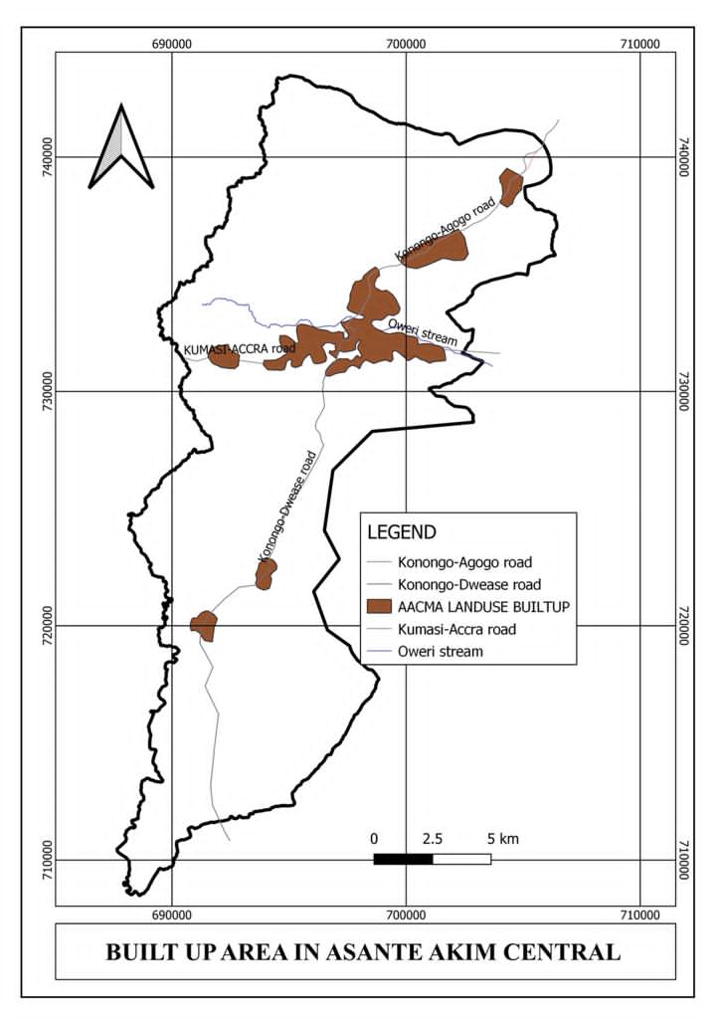Built- up areas of Asante Akim Central Municipal
- VISION OF THE DISTRICT ASSEMBLY
Asante Akim Central Municipal Assembly aspires to become a safe and peaceful Municipality of prosperous people with excellent infrastructure and services delivered by a peak performing Assembly in partnership with stakeholders.

- MISSION STATEMENT OF THE DISTRICT ASSEMBLY
The Asante Akim Central Municipal Assembly exists to ensure a better standard of living by providing the right leadership in the development of infrastructure and delivery of socio-economic services through stakeholder participation with equal opportunity for all

- KEY ACHIEVEMENTS IN 2021
The Assembly was able to complete these projects in 2021
Key Achievements
S/N | PROGRAMME/PROJECTS
1. | Construction of 2 No Pavilion at St. Marys and Wesley High School
2. | Rehabilitation of Odumase Market
3. | Completion of 1 No 3 unit classroom block at Kyekyebiase
4. | Completion of ICT centre at Dwease
5 | Supply of Electrical Accessories
6. | Reshaped of Urban and feeder roads in the municipality
7. | Construction of 1 No. 3 unit classroom block at Abosometweagya with Ancillary

Prioritized Aspirations by Zonal Councils
Zonal Council | Prioritized Community Aspirations
Konongo- Odumase | Construction/rehabilitation of school blocks  Provision of furniture for schools  Good governance (Zonal council office/police  Extension of electricity  Provision of potable water  Provision of market  Provision of improved sanitation  Provision of health facilities  Rehabilitation of roads  Provision of affordable farm inputs.  Provision of improved service delivery
Dwease- Praaso | Improve agricultural productivity  Provision of improved health care  Provision of furniture for schools  Construction/rehabilitation of educational infrastructure  Provision of potable water  Extension of electricity  Provision of improved sanitation  Rehabilitation of feeder roads
Oweregya | Good governance  Provision of furniture for schools  Provision of improved sanitation  Provision of potable water  Extension of electricity (Energy)  Provision of improved healthcare  Provision of market (Trade)  Improved Agricultural productivity  Construction/rehabilitation of educational infrastructure  Roads

Source: MPCU, 2021

- REVENUE AND EXPENDITURE PERFORMANCE
- REVENUE PERFORMANCE
Table 3: Revenue Performance - IGF
REVENUE PERFORMANCE- IGF ONLY

ITEM | 2019 |  |  |  |  |  | 2020 |  |  |  |  |  | 2021 |  |  |  |  | % performance at Jul,2021
ITEM | Budget |  |  | Actual |  |  | Budget |  |  | Actual |  |  | Budget |  |  | Actual as at July
Rate | 272,000.00 |  |  | 115,071.93 |  |  | 27,3475.21 |  |  | 85,076.16 |  |  | 5,000 |  |  | 853.00 |  | 17.1
Fees | 261,298.00 |  |  | 185,262.02 |  |  | 459,120.16 |  |  | 186,338.93 |  |  | 468,460.00 |  |  | 199,714.00 |  | 35.0
Fines | 119,900.00 |  |  | 59,340.00 |  |  | 116,400.00 |  |  | 249,323.66 |  |  | 120,560.00 |  |  | 8,870.00 |  | 33.55
Licenses | 248,685.00 |  |  | 216,490.85 |  |  | 252,000.00 |  |  | 18,255.00 |  |  | 303,825.00 |  |  | 126,361.59 |  | 41.59
Land | 163,200.04 |  |  | 147,295.00 |  |  | 162,850.00 |  |  | 163,391.00 |  |  | 170,860.00 |  |  | 81,140.00 |  | 49.67
Rent | 22,614.96 |  |  | 7,242.00 |  |  | 76,190.00 |  |  | 18,225.00 |  |  | 77,870.00 |  |  | 46,005.00 |  | 59.08
Miscellaneous | 3,150.00 |  |  | 401.37 |  |  | 3,000 |  |  | 4,994.49 |  |  | 3000 |  |  | 300 |  | 38.6
Total | 1,090,848.00 |  |  | 731,103.17 |  |  | 1,275,710.21 |  |  | 857,092.84 |  |  | 1,420,480.21 |  |  | 548,319.75 |  | 38.6
REVENUE PERFORMANCE- ALL REVENUE SOURCES
ITEM |  | 2019 |  |  |  |  |  | 2020 |  |  |  |  |  |  | 2021 |  |  |  |  | % performance as at July,2021
 |  | Budget |  |  |  | Actual |  | Budget |  |  |  | Actual |  |  | Budget |  | Actual
IGF |  | 1,185,080.00 |  |  |  | 731,103,31 |  | 1,275,860.21 |  |  |  | 863,659.84 |  |  | 1,420,480.21 |  | 548,319,.75 |  |  | 38.6
Compensation Transfer |  | 2,184,594.00 |  |  |  |  |  | 2,459,864.72 |  |  |  | 1,821,918.84 |  |  | 2,459,864.72 |  | 1,236,351.76 |  |  | 50.3
Goods and Services transfer |  | 41,765.00 |  |  |  |  |  | 64,043.51 |  |  |  | 158,042.37 |  |  | 110,047.20 |  | 0
Assets Transfer
DACF |  | 3,686,941.41 |  |  |  | 1,488,045.83 |  | 3,574,578.42 |  |  |  | 2,123,905.05 |  |  | 4,468,620.07 |  | 1,505951.99 |  |  | 33.7
DDF |  |  | 480,777.00 |  | - |  |  |  | 480,777.00 |  | 422,633.00 |  |  | 466,000.00 |  |  | 465,678.00 |  | 99.9
UDG |  |  | 1,497,500.00 |  | 1,560,864.18 |  |  |  | -
(MOFA) CIDA |  |  |  |  |  |  |  |  | 75,000.00 |  |  |  |  | 172,948.68 |  |  | 132,171.21 |  | 76.4
Total |  |  | 9,076,657.41 |  | 6,020,287 |  |  |  | 8,202,193.65 |  | 5,390,159.10 |  |  | 9,097,961.53 |  |  | 4,199,602.98 |  | 46.2
- EXPENDITURE PERFORMANCE

EXPENDITURE PERFORMANCE (ALL DEPARTMENTS) IGF ONLY
Expenditure | 2019 |  | 2020 |  | 2021 |  | % age  Performance (as at July 2021)
Expenditure | Budget | Actual | Budget | Actual | Budget | Actual as at July. | % age  Performance (as at July 2021)
Compensation | 260,221.00 | 237,989.89 | 280,530.57 | 271,072.00 | 281,020.21 | 102,967.37 | 36.6
Goods and Services | 739,007.00 | 304,510.50 | 888,887.50 | 214,836.20 | 904,190.26 | 401,852.38 | 44.4
Assets | 185,852.00 | 72,910.45 | 106,443.00 | 20,500.00 | 220,270.00 | 43,500.00 | 19.7
Total | 1,036,432.20 | 615,410.84 | 1,275,860.21 | 506,408.20 | 1,420,371.20 | 548,319.75 | 38.6
Table 4: Expenditure Performance

EXPENDITURE PERFORMANCE (ALL DEPARTMENTS) GOG ONLY
Expenditure | 2019 |  | 2020 |  | 2021 |  | % age  Performance (as at July 2021)
Expenditure | Budget | Actual | Budget | Actual | Budget | Actual as at July | % age  Performance (as at July 2021)
Compensation | 2,184,594.00 | 2,182,773.05 | 2,459,864.60 | 1,821,918.84 | 2,459,864.72 | 1,261,695.75 | 51.3
Goods and Services | 41,765,00 | 20,000.00 | 100,831.31 | 158,042.37 | 110,470.00 | -
Assets | - | - | - | - | - | -
Total | 2,184,594.00 | 2,202,773.05 | 2,536,584.99 | 1,979,961.21 | 2,570,334.72 | 1,261,695.75 | 49.1

PART B: STRATEGIC OVERVIEW
- NMTDF POLICY OBJECTIVE IN LINE WITH SDGs AND TAGETS AND COST
FOCUS AREA | POLICY OBJECTIVE | SDGS | SDG TARGETS | BUDGET
Build a Prosperous Society | Improve production efficiency  and yield | Goal 8 Promote sustained inclusive and sustainable economic growth full and productive employment and decent work for all | 8 .2 Achieve higher levels of economic, productivity through diversification, technological upgrading and innovation, including through a focus on high-value added and labor-intensive sectors | 1,063,145.00
Build a Prosperous Society | Improve production efficiency  and yield | Goal 2  End hunger, achieve food security and improved nutrition and promote sustainable agriculture | 2.3 By 2030, double the agricultural productivity and incomes of small scale food producers, in particular women, indigenous peoples, family farmers, pastoralists and fishers, including through secure and equal access to land, other productive resources and inputs, knowledge, financial services. | 1,063,145.00
Table 5: Policy Objectives In Line With SDGs and Targets and Cost

FOCUS AREA | POLICY OBJECTIVE | SDGS | SDG TARGETS | BUDGET
Create opportunities for all | Enhance inclusive and equitable access to, and participation in quality education at all levels  Achieve access to adequate and equitable sanitation and hygeine | Goal 4. Ensure inclusive and equitable quality education and promote lifelong learning opportunities for all | 4.3 By 2030, ensure equal access for all women and men to affordable and quality technical, vocational and tertiary education, including university | 2,807,246.00
Create opportunities for all |  | Goal 3. Ensuring healthy lives and promoting the well-being at all ages | 3.8 Achieve universal health coverage, including financial risk protection, access to quality essential health-care services and access to safe, effective, quality and affordable essential medicines and vaccines for all | 2,807,246.00
Create opportunities for all |  |  | 3.2 By 2030, end preventable deaths of newborns and children under 5 years of age, with all countries aiming to reduce neonatal mortality to at least as low as 12 per 1,000 live births and under-5 mortality to at least as low as 25 per 1,000 live births

FOCUS AREA | POLICY OBJECTIVE | SDGS | SDG TARGETS | BUDGET
Create opportunities for all | Facilitate sustainable and resilient infrastructure development | Goal 11: make cities and human settlement inclusive, safe, resilient and sustainable | 11.1 By 2030, ensure access for all to adequate, safe and affordable housing and basic services and upgrade slum. | 2,430,254.00
Create opportunities for all |  |  | 11.2 by 2030, provide access to safe, affordable, accessible and sustainable transport system for all improving road safety, notably by expanding public transport with special attention to needs of those in vulnerable situations, women, children, persons with disability and older persons | 2,430,254.00

FOCUS AREA | POLICY OBJECTIVE | SDGS | SDG TARGETS | BUDGET
Safeguard the natural environment and ensure a resilient built environment | Reduce vulnerability to climate-related event and disasters | Goal 13: Take urgent action to combat climate change and its impact | 13. 1 Strengthen resilient and adaptive capacity to climate-related hazards and natural disasters in all countries | 100,000.00
 | Reduce vulnerability to climate-related event and disasters |  | 13.3 Improve education, awareness-raising and human and institutional capacity on climate change mitigation, early warning adaptation, impact reduction and early warning | 100,000.00

FOCUS AREA | POLICY OBJECTIVE | SDGS | SDG TARGETS | BUDGET
Maintain a stable, united and safe society | Implement appropriate social protection system and measures | Goal 16: promote peaceful and inclusive societies for sustainable development, provide access to justice for all and build effective, accountable, and inclusive institutional levels | 16.1 Significantly reduce all forms of violence and related death rates everywhere | 534,194.00
Maintain a stable, united and safe society |  | Goal10: Reduce Inequality within and among countries | 16.2 End abuse, exploitation, trafficking and all forms of violence and torture of children | 534,194.00

- GOAL
The goal of the Asante Akim Central Municipal Assembly is to create an enabling environment for the development and growth of the municipality through modernized agriculture, increased industrial activities, deepening decentralization within the framework of increased Public-Private Partnership in a clean, crime and violence free environment that offers adequate basic social services.
- CORE FUNCTIONS
The core functions of the Municipal Assembly include the following:
- Formulation and execution of plans, programs and strategies for the overall development of the Municipality
- Provision of infrastructure e.g. schools, clinics, etc.
- Formulation and approval of composite budget and making of bye-laws.
- Levying and collection of taxes, rates, fees, etc. to generate revenue.
- Promotion of justice by ensuring ready access to the courts in the Municipality.
- Maintenance of security and public safety in the Municipality
- Ensuring proper sanitation management in the Municipality.
- Preparation of land use plans (structure and local plans) to direct and guide the growth and sustainable development of human settlements in the Municipal area.
- The promotion and protection of the rights of children.
- Training of women, artisans and medium/small scale entrepreneurs in business development skills and Provision of extensions service to farmers.
- Assist in the formulation and implementation of policies on Education and Health in the Municipality, within the framework of National Policies and guidelines
- Provision of layout for buildings for improved housing layout and settlement.

- POLICY OUTCOME INDICATORS AND TARGETS
Table 6: Policy Outcome Indicators and Targets
Outcome Indicator Description | Unit of Measurement | Baseline |  | Latest Status |  | Target
Outcome Indicator Description | Unit of Measurement | Year | Value | Year | Value | Year | Value
Increase in the number of educational infrastructure | Number of classrooms | 2018 | 624 | 2019 | 628 | 2020 | 631
Increase access to health infrastructure | Number of health facilities provided | 2018 | 4 | 2019 | 5 | 2020 | 6
Upgrade market infrastructure | Number of market facilities upgraded | 2018 | 1 | 2019 | 1 | 2020 | 1
Improvement in business development skills | Number of business/skills development trainings organised | 2018 | 20 | 2019 | 12 | 2019 | 25
Increase stakeholders participation | Number of stakeholders meetings organised | 2018 | 4 | 2019 | 2 | 2020 | 4
Build capacity of land owners and Chiefs on settlement planning | Number of development application processed | 2018 | 95 | 2019 | 125 | 2020 | 350
National Digital Addressing system of Asante Akim Central Municipal Assembly | Number of street and properties named and numbered | 2018 | 20 | 2019 | 55 | 2020 | 350
Economic empowerment of PWDs | Number of PWDs supported | 2018 | 145 | 2019 | 33 | 2020 | 120
Alleviate extreme poverty | Number of persons supported | 2018 | 275 | 2019 | 402 | 2020 | 500
Child right and family welfare promoted | Number of cases resolved | 2018 | 134 | 2019 | 100 | 2020 | 152

REVENUE MOBILIZATION STRATEGIES FOR KEY REVENUE SOURCES IN 2020.
REVENUE SOURCE | KEY STRATEGIES
- RATES (Basic Rates/Property Rates) | -Sensitize the public on the need to pay rate  -Update data on all properties within the municipality  -Undertake property valuation and revaluation exercise
- LANDS | -Ensure that land developers who submit their building permit are processed within one month  -Sensitize the public on the need to register their plots and acquire permit before building  -Prosecute land developers who build without permits to serve as deterrent to others
- LICENSES | -Sensitize the private business operators to register their business and renew the licenses very year
4. RENT | -Engage and enforce that occupants pay their rent  -Regular maintenance of buildings to motivate tenants to pay their rents
5.FEES AND FINES | -Task force to monitor and assess revenue on market day  -Prosecute defaulters to take fines when applicable  -Regular monitoring of fees such as market/lorry park tolls and burial fees  - Regular maintenance of Assembly facilities
6.GENERAL STRATEGIES | -Use computer software to generate bills and demand notice/point of sale device  -Ceding parts of the revenue item to the zonal council  -Engagement of Melchia private agent to assist in revenue collection  -Training for revenue collectors  - Motivating hardworking collectors and sanction recalcitrant collectors

PART C: BUDGET PROGRAMME SUMMARY

PROGRAMME 1: MANAGEMENT AND ADMINISTRATION
1. Budget Programme Objectives
To provide support services, effective and efficient general administration and organization of the Municipal Assembly.
To ensure sound financial management of the finances of the Assembly's and effective and efficient management of the other resources of the Assembly

2. Budget Programme Description
The programme seeks to provide administrative and logistical support services required to create an enabling environment. The programme relates to the Management and Administration of the Assembly which comprises General Administration, Finance Unit, Human Resource Unit, Planning Unit, Budgeting Unit and Monitoring and evaluation Unit, Records Section, Logistics and Procurement Section and Stores Section.
The programme is being implemented with the total support of all staff of the Central Administration and Finance Departments. Total staff strength of Fifty-Six (56) is involved in the delivery of the programme
The Programme is being funded with the Assembly’s Internally Generated Fund and Government of Ghana transfer namely; the District Assemblies’ Common Fund and District Development Facility.

BUDGET SUB-PROGRAMME SUMMARY

PROGRAMME1: Management and Administration

SUB-PROGRAMME 1.1 General Administrations

- Budget Sub-Programme Objective
The programme seeks to provide administrative support and ensure effective co-ordination of all the various decentralised departments and units of the Assembly.

- Budget Sub-Programme Description
The sub-programme looks at the provision of administrative support and effective coordination of the activities of the various Departments and Units under the Assembly through the Office of the Co-ordinating Director.
The operations include;
  - Provision of general information and direction as well as the establishment of standard procedures of operation for the effective and efficient running of the Assembly;
  - Consolidation and incorporation of the Assembly’s needs for equipment, logistic and materials into a master procurement plan;
  - Preparation and maintenance of proper accounting records, books and reports;
  - Ensuring budgetary control and management of assets, liabilities, revenue and expenditures;
  - Ensuring inventory and stores management.

The number of staff delivering the sub programme comprises 1 from Procurement Unit, 2 from Internal Audit, Four (4) from Administrative class, One (1) from Stores, Four (4) from Records, Five (5) drivers, Two (2) Radio Operators, One (1) Local Government Inspector, Thirteen (13) Securities and One (1) Secretaries.
The beneficiaries of this sub-programme are the decentralized departments/departments of the Assembly and the general public.
The Programme is being funded with the Assembly’s Internally Generated Fund and Government of Ghana transfer namely the District Assemblies’ Common Fund and District Development Facility.
The main challenges this sub programme will encounter are inadequate Central Government Transfer, delay and untimely release of funds, inadequate Internally Generated funds.

- Budget Sub-Programme Results Statement
The table indicates the main outputs, its indicators and projections by which the MMDAs measure the performance of this sub-programme. The past data indicates actual performance whilst the projections are the MMDA’s estimate of future performance.
Table 7: Budget Results Statement - Administration
Main Outputs | Output Indicator | Past Years |  | Projections
Main Outputs | Output Indicator | 2018 | 2019 | Budget Year  2020 | Indicative Year  2021 | Indicative Year  2022 | Indicative Year  2023
Public Education/ Fora | Number of Public Fora organised | 4 | 2 | 4 | 4 | 4 | 4
Monitoring of development projects | Number of monitoring Activities undertaken | 7 | 10 | 12 | 12 | 12 | 12
Internal Audit Report prepared quarterly and submitted to the Presiding Member | Report on Audit Assignments conducted | 4 | 3 | 4 | 4 | 4 | 4
Procurement and Maintenance of Office Equipment | Number of Office Computers procured | 6 | 5 | 6 | 6 | 6 | 6
Procurement and Maintenance of Office Furniture | Number. of Office Furniture maintained | 50 | 50 | 55 | 55 | 55 | 55

- Budget Sub-Programme Operations and Projects
The table below indicates the main Operations and projects to be undertaken by the sub-programme
Table 8: Main Objectives and Projects
Operations |  | Projects
Internal Management of the Organization
Procurement of Office Supplies & Consumables
Procurement of building materials for Self Help project.
Support to security services
Support to Sub-structure

BUDGET SUB-PROGRAMME SUMMARY
PROGRAMME1: Management and Administration

SUB-PROGRAMME 1.2 Finance and Revenue Mobilization
- Budget Sub-Programme Objective
To ensure sound financial management of the Assembly's resources. To ensure the mobilization of all available revenues for effective service delivery
- Budget Sub-Programme Description
The Finance sub- programme comprises of two units namely, the Accounts and Treasury. The units collect record and summarise financial transactions into financial statements and reports. They assist management and other stakeholders in financial decision making. It receives, keeps safe custody and disburses public funds.
The sub-program operations include;

- Undertaking revenue mobilization activities of the Assembly
- Keeping receipts and custody of all public and trust monies payable into the Consolidated Fund
- Facilitating the disbursement of legitimate and authorized funds
- Preparing financial reports at specific periods for the Assembly
- Preparing payment vouchers and financial encumbrances

The sub-programme is proficiently manned by Twenty-One (21) Officers. Funding for the Finance sub-programme is from the Assembly’s Internally Generated Fund and District Assemblies’ Common Fund. The beneficiaries include Controller and Accountant General Department and the general public.
- Budget Sub-Programme Results Statement
The table indicates the main outputs, its indicators and projections by which the MMDAs measure the performance of this sub-programme. The past data indicates actual performance whilst the projections are the MMDA’s estimate of future performance.
Table 9: Budget Results Statement - Finance and Revenue Mobilization
Main Outputs | Output Indicator | Past Years |  | Projections
Main Outputs | Output Indicator | 2018 | 2019 | Budget Year  2020 | Indicative Year  2021 | Indicative Year  2022 | Indicative Year  2023
Prepare and submit Annual and Monthly Financial Statement of Accounts to CAGD | Annual Statement of Accounts submitted | 31st March | 31st March | 31st March | 31st March | 31st March | 31st March
 | Number of monthly Financial Reports submitted | 12 | 7 | 12 | 12 | 12 | 12

- Budget Sub-Programme Operations and Projects
The table lists the main Operations and projects to be undertaken by the sub-programme

Table 10: Main Operations and Projects
Operations |  | Projects
Internal Management |  | Valuation of properties
Public Education on Revenue Mobilization
Revenue Collection
Monitoring and evaluation of revenue
Supervision of Revenue Collectors
Training for Revenue Collectors

BUDGET SUB-PROGRAMME SUMMARY
PROGRAMME1: Management and Administration

SUB-PROGRAMME 1.3 Planning, Budgeting and Coordination
- Budget Sub-Programme Objective
To ensure the preparation of the Assembly’s Annual Action Plan and budget
To develop effective monitoring and evaluation system to measure achievements of policy and Programme objectives against set targets.
- Budget Sub-Programme Description
The Sub-programme develops, reviews, monitors and evaluates the implementation of all the policies, strategies and Programmes to ascertain their impact on goals and outcomes that the Assembly expects to achieve.
The key operations are:
- Policy formulation
- Budget and Annual Action Preparation
- Budget Performance Reporting
- Management and Monitoring Policies, Programmes and Projects
The number of staff delivering the sub-program is 5, out of this, 2 are from the Planning Unit and 3 from Budget Unit.
This sub-programme is funded by Government of Ghana with funds from the Districts Assemblies Common Fund. The program is also funded with the Internally Generated Fund.

The beneficiaries of this sub- programme are the departments of the assembly, units and the general public.
The challenges include Inadequate funding, for planned programme and activities and inadequate revenue data.
Budget Sub-Programme Results Statement
The table indicates the main outputs, its indicators and projections by which the MMDAs measure the performance of this sub-programme. The past data indicates actual performance whilst the projections are the MMDA’s estimate of future performance.
Table 11: Budget Results Statement – Planning, Budgeting and Coordination
in Outputs | Output Indicator | Past Years |  | Projections
in Outputs | Output Indicator | 2018 | 2019 | Budget Year  2020 | Indicative Year  2021 | Indicative Year  2022 | Indicative Year  2023
Composite Budget prepared based on Composite Annual Action Plan | Report on Composite Budget approved by General Assembly by | 31st October | 24th September | 30th September | 30th September | 30th September | 30th September
Monitoring of development Projects | Report on No. of Monitoring Activities undertaken | 12 | 10 | 12 | 12 | 12 | 12

- Budget Sub-Programme Operations and Projects
The table lists the main Operations and projects to be undertaken by the sub-programme
Table 12: Main Objectives and Projects
Operations |  | Projects
Preparation of Action plan and Composite Budget
Project management and monitoring
Revision of Medium Term Budget Development plan
Preparation of Fee Fixing Resolution
Collection of socio economic and revenue data
Preparation of composite budget
Organisation of stakeholders for a

BUDGET SUB-PROGRAMME SUMMARY
PROGRAMME1: Management and Administration

SUB-PROGRAMME 1.5 Human Resource Management
- Budget Sub-Programme Objective
To improve and enhance the capacity of staff for the effective and efficient delivery of public services
- Budget Sub-Programme Description
The sub-programme considers the human resource need of the assembly, it facilitates training and placement. It also ensures regular update of staff records and efficient management of human resources of the municipal assembly.
Two (2) officers are delivering this programme and all staff of the Assembly are beneficiaries. It is funded by Government of Ghana transfers, District Development Facility, DACF and Internally Generated Fund. The challenges include inadequate staffing levels, inadequate office space.
- Budget Sub-Programme Results Statement
The table indicates the main outputs, its indicators and projections by which the MMDAs measure the performance of this sub-programme. The past data indicates actual performance whilst the projections are the MMDA’s estimate of future performance.

Table 13: Budget Results Statement – Human Resource Management
Main Outputs | Output Indicator | Past Years |  | Projections
Main Outputs | Output Indicator | 2018 | 2019 | Budget Year  2020 | Indicative Year  2021 | Indicative Year  2022 | Indicative Year  2023
Staff capacity building a | No. of Local Training programmes organized | 5 | 4 | 4 | 4 | 4 | 4
Staff capacity building a | No. of staff supported for external training | 4 | 0 | 2 | 2 | 2 | 2
Annual Appraisal of staff | Number of staff Appraisal conducted | 165 | 0 | 126 | 126 | 126 | 126

- Budget Sub-Programme Operations and Projects
The table lists the main Operations and projects to be undertaken by the sub-programme
Table 14: Main Operations and Projects
Operations |  | Projects
Capacity Building of staff
Appraisal of staff
Preparation of Composite Training plan

BUDGET PROGRAMME SUMMARY

PROGRAMME 2: INFRASTRUCTURE DELIVERY AND MANAGEMENT
- Budget Programme Objectives
Provision of civil works (Roads, Public Buildings, Rural Housing, Water and Sanitation) by providing designs, working drawings and preparation of tender documents and advise the Municipal Assembly on national policies on physical planning, land use and development.
- Budget Programme Description
The various organization tasked with the responsibility of delivering the programme include Urban Roads, Physical Planning and Works Departments.
The Urban Roads and Transport departments are responsible for the administration, planning, development and maintenance of the urban road networks in the Municipality.
The Spatial Planning sub-programme also seeks to advise the Municipal Assembly on national policies on physical planning, land use and development.
The Department of Works of the District Assembly is a merger of the former Public Works Department, Department of Feeder Roads of the Assembly and it is responsible for assisting the Assembly to formulate policies on works within the framework of national policies.
The number of staff manning this programme is Nineteen (19) with funding from Government of Ghana transfers, District Development Facility and Internally Generated Funds of the Assembly. The beneficiaries of the programme include urban and rural dwellers in the Municipality and the general public.

BUDGET SUB-PROGRAMME SUMMARY
PROGRAMME2: INFRASTRUCTURE DEVELOPMENT AND MANAGEMENT

SUB-PROGRAMME 2.1 Urban Roads and Transport Services
- Budget Sub-Programme Objective
- To assist in building capacity to provide quality urban road transport systems for the safe mobility of goods and people in the Municipality.

- Budget Sub-Programme Description
The sub-programme Urban Roads and Transport Services is dedicated to the decentralized road units for the provision and management of the urban road network in support of quality systems. The sub-programme is being delivered by the Urban Roads and Transport Departments.

The sub-program operations include;
- Collecting data for planning and development of the infrastructure in the Municipality.
- Establishing and maintaining a database on urban infrastructure in the Municipality.
- Facilitate the prioritization of works and preparation of annual plans for infrastructure works.
- Advise the Assembly on matters relating to transport services.
- Prohibit or restrict the driving of general or any specified vehicles on specified roads or specified direction.

This sub programme is manned by only Two (2) staff an Engineer and secretary with funds from DACF and Assembly’s Internally Generated Funds. The beneficiaries of the sub-program are the entire citizenry in the Municipality. Key challenges facing this sub-programme include inadequate staffing levels and untimely releases of funds.

- Budget Sub-Programme Results Statement
The table indicates the main outputs, its indicators and projections by which the Municipal Assembly measure the performance of this sub-programme. The past data indicates actual performance whilst the projections are the Assembly’s estimate of future performance.
Table 15: Budget Results Statement – Urban Roads and Transport Services
Main Outputs | Output Indicator | Past Years |  | Projections
Main Outputs | Output Indicator | 2018 | 2019 | Budget Year  2020 | Indicative Year  2021 | Indicative Year  2022 | Indicative Year  2023
Construction/Rehabilitation of roads | Kilometre of roads rehabilitated | 2.5km | 20km | 20km | 20km | 20km | 20km

- Budget Sub-Programme Operations and Projects
The table lists the main Operations and projects to be undertaken by the sub-programme
Table 16: Main Objectives and Projects
Operations |  | Projects
Internal Management |  | Rehabilitation of Roads

BUDGET SUB-PROGRAMME SUMMARY
PROGRAMME2: Infrastructure Delivery and Management

SUB-PROGRAMME 2.2 Physical and Spatial Planning
- Budget Sub-Programme Objective
To plan, control and ensure a harmonious, sustainable and cost effective development of human settlements in accordance with sound environmental and planning principles
- Budget Sub-Programme Description
The Spatial Planning sub-programme is delivered through the Department of Physical Planning and tasked to manage the activities of the former department of Town and Country Planning and the department of Parks and Gardens in the Municipality.
The sub-program operations include;
- Preparation of land use plans (structure and local plans) to direct and guide the growth and sustainable development of human settlements in the Municipal area.
- Assessment of zoning status of land and proposals for rezoning where necessary
- Coordination of diverse physical developments prompted by government departments/agencies and private developers
- Administration of land use management in the settlement and channelling of day to day physical development into efficient forms and sound environmental places of residence, work and recreation
- Processing of development/building permit application documents for consideration by the Statutory Planning Committee
- Creating awareness about the need to obtain planning and development permits as well as the right procedures
The department has total staff of 9.
This sub programme is funded from the Central Government transfers and Internally Generated Funds. The beneficiaries are the entire citizenry in the Municipality.
The department is faced with the key challenges such as inadequate staffing levels, inadequate office space, and untimely releases of funds and lack of vehicle to undertake monitoring.

- Budget Sub-Programme Results Statement
The table indicates the main outputs, its indicators and projections by which the MMDAs measure the performance of this sub-programme. The past data indicates actual performance whilst the projections are the MMDA’s estimate of future performance.
Table 17: Budget Results Statement – Physical and Spatial Planning
Main Outputs | Output Indicator | Past Years |  | Projections
Main Outputs | Output Indicator | 2018 | 2019 | Budget Year  2020 | Indicative Year  2021 | Indicative Year  2022 | Indicative Year  2023
Build capacity of land owners and chiefs on settlement planning | No of town and country layout prepared  No of town and sector layout prepared | 95 | 125 | 140 | 140 | 140 | 140
National Digital Addressing system | Number of Street and properties named and numbered | 20 | 55 | 350 | 350 | 350 | 350

- Budget Sub-Programme Operations and Projects
The table lists the main Operations and projects to be undertaken by the sub-programme
Table 18: Main Objectives and Projects
Operations |  | Projects
Internal Management
Preparation of layout
Street naming and property addressing
Processing of building permits

BUDGET SUB-PROGRAMME SUMMARY
PROGRAMME2: Infrastructure Delivery and Management
SUB-PROGRAMME 2.2 Public Works, Rural Housing, and Water Management

1. Budget Sub-Programme Objective
To implement development programmes to enhance rural transport through improved feeder and farm road network and portable water supply.
To improve service delivery to ensure quality of life in rural areas

2. Budget Sub-Programme Description
The sub-programme is tasked with the responsibility of developing and implementing appropriate strategies and programmes that aims to improve the living conditions of rural dwellers. The department of Works comprising of former Public Works, Feeder Roads, and Rural Housing Department is delivering the sub-programme.

The sub-program operations include;
- Facilitating the implementation of policies on works and report to the Assembly
- Advising the Assembly on matters relating to works in the Municipality
- Assisting in the preparation of tender documents for all civil works projects to be undertaken by the Assembly through contracts or community initiated projects.
- Facilitating the construction, repairs and maintenance of public roads including feeder roads and drains along any streets in the major settlements in the Municipality.
- Facilitating the provision of adequate and wholesome supply of potable water for the entire Municipality.
- Assisting in the projects inspection and monitoring undertaken by the Municipal Assembly.
This sub programme is funded from the Central Government transfers and IGF. The beneficiaries are the entire citizenry in the Municipality. The sub-programme is managed with total staff strength of 10. A key challenge encountered in delivering this sub-programme includes untimely releases of funds and lack of vehicle to undertake project inspection.

3. Budget Sub-Programme Results Statement
The table indicates the main outputs, its indicators and projections by which the MMDAs measure the performance of this sub-programme. The past data indicates actual performance whilst the projections are the MMDA’s estimate of future performance.
Table 19: Public Works, Rural Housing, and Water Management
Main Outputs | Output Indicator | Past Years |  | Projections
Main Outputs | Output Indicator | 2018 | 2019 | Budget Year  2020 | Indicative Year  2021 | Indicative Year  2022 |  | Indicative Year  2023
Maintenance of Public Buildings | No of Staff Bungalows Renovated | 5 | 2 | 5 | 5 |  | 5 | 5
Increase access to potable water | No. of boreholes drilled and mechanized | 3 | 2 | 10 | 5 |  | 5 | 5
Expansion of electricity access | No. of electricity poles procured and distributed | 80 | 0 | 100 | 120 |  | 120 | 120
Construction and Maintenance of market structures of Market | No. of markets constructed | 1 | 1 | 1 | 1 |  | 1 | 1
Construction and Maintenance of market structures of Market | No. of Markets rehabilitated | 1 | 1 | 1 | 1 |  | 1 | 1

4. Budget Sub-Programme Operations and Projects
The table lists the main Operations and projects to be undertaken by the sub-programme
Table 20: Main Objectives and Projects
Operations |  | Projects
Internal Management |  | Renovation of Assembly Properties
Monitoring of Projects |  | Maintenance of market in the municipality
 |  | Procurement of electricity poles and accessories
 |  | Construction of 10 No Boreholes

BUDGET PROGRAMME SUMMARY

PROGRAMME 3: SOCIAL SERVICES DELIVERY
- Budget Programme Objectives
To promote social services delivery through quality, accessible and affordable healthcare and education.

- Budget Programme Description
This sub-programme seeks to provide the necessary logistics for quality education and improve the health needs of the people in the Municipality.
The key operations include:
- Provide quality, accessible and affordable health care to the populace
- Provide equitable access to education at all levels
- Promote gender, aged, children and social protection related policies.
- Provide quality data on birth and death registration
- Provide necessary equipment to improve sanitation management
- The beneficiaries of this sub-program are the decentralized departments and the general public.
The various department involved in the delivery of the program include; Ghana Education Service, Ghana Health Services, Environmental Health Unit, Social Welfare & Community Development and Birth & Death Registry
This sub-Program is being funded with the Internally Generated Fund and Government of Ghana transfer namely the District Assemblies’ Common Fund and District Development Facility.
The Number of staff to carry out this programme is Forty-Eight (48) excluding those from Ghana Health Service and Ghana Education Service. The beneficiary of this programme is the general public.
The main challenges this sub programme will encounter are inadequate Motorbike to undertake supervision and education and inadequate and late release of funds.

BUDGET SUB-PROGRAMME SUMMARY
PROGRAMME3: SOCIAL SERVICES DELIVERY

SUB-PROGRAMME 3:1 Education and Youth Development
- Budget Sub-Programme Objective
The main objective of this sub-programme is to formulate, plan and implement education policies within the framework of national education policies and guidelines provided by the Minister of Education and Ghana Education Service
- Budget Sub-Programme Description
This sub-programme implements policies set by the Ministry of Education and the Ghana Education Service at the municipality. The department is responsible for basic education delivery and the development and organization of sports and library services at the Pre-school, special school and basic education level

The sub-programme operations include; Community Sensitization, In-service Training for Teachers, Comprehensive School Inspection, Training of school management Committees, Municipal Education Oversight Committee meetings and Refresher workshops for Heads of Basic schools on school management.
This sub-programme is being funded through the Assembly’s Budget Internally Generated Funds and Government of Ghana transfer namely the District Assemblies’ Common Fund and District Development Facility.
The beneficiary of this programme is the general public, Ghana Education Service and Ministry of Education.

Budget Sub-Programme Results Statement
The table indicates the main outputs, its indicators and projections by which the MMDAs measure the performance of this sub-programme. The past data indicates actual performance whilst the projections are the MMDA’s estimate of future performance.
Table 21: Budget Results Statement – Education and Youth Development
Main Outputs | Output Indicator | Past Years |  | Projections
Main Outputs | Output Indicator | 2018 | 2019 | Budget Year  2020 | Indicative Year  2021 | Indicative Year  2022 | Indicative Year  2023
Financial assistance to needy but brilliant student | No of students assisted | 58 | 58 | 70 | 80 | 90 | 100
Renovation and expansion of educational infrastructure | No of classroom blocks constructed | 5 | 5 | 3 | 4 | 4 | 4

- Budget Sub-Programme Operations and Projects
The table lists the main Operations and projects to be undertaken by the sub-programme
Table 22: Main Operations and Projects
Operations |  | Projects
Internal Management |  | Construction of 1 No 3Unit Block at Ohenenkwanta
 |  | Construction of Pavilion at Wesley and St. Mary’s High School
 |  | Support to Ekoso School Project
 |  | Provision of Mono and Dual Desk for schools in the municipality
 |  | Completion of 1 No 3 Unit Classroom Block at Kyekyewere
BUDGET SUB-PROGRAMME SUMMARY
PROGRAMME3: SOCIAL SERVICES DELIVERY

SUB-PROGRAMME 3.2: Health Delivery
- Budget Sub-Programme Objective
The Ghana Health Service provides and manages comprehensive and accessible health services with special emphasis on primary health care at the District and sub-district levels in accordance with approved national policies
- Budget Sub-Programme Description
The sub-programme aims at providing health facilities as well as health education and other programmes for effective and efficient promotion of public health in the Municipality.
The sub-programme operations include;
Implement approved national policies for health delivery in Ghana
- Advise the Municipal Assembly on the construction and rehabilitation of clinics and health centres or provision of health facilities in the Municipality;
- Undertake health education and family immunization and nutrition programmes;
- Facilitates disease control and prevention.
The sub-programme would be delivered through the offices of the Municipal Health Directorate and funding source includes Government of Ghana transfers, Donor Support and Internally Generated Funds of the Assembly. The beneficiaries of the sub-program are the entire citizenry in the Municipality.
Challenges militating against the success of this sub-programme include delay and untimely release of funds and inadequate logistics.

- Budget Sub-Programme Results Statement
The table indicates the main outputs, its indicators and projections by which the MMDAs measure the performance of this sub-programme. The past data indicates actual performance whilst the projections are the MMDA’s estimate of future performance.
Table 23: Budget Results Statement – Health Delivery
Main Outputs | Output Indicator | Past Years |  | Projections
Main Outputs | Output Indicator | 2018 | 2019 | Budget Year  2020 | Indicative Year  2021 | Indicative Year  2022 | Indicative Year  2023
Expansion of Health facilities | No. of health facilities constructed | 2 | 2 | 1 | 2 | 2 | 2

- Budget Sub-Programme Operations and Projects
The table lists the main Operations and projects to be undertaken by the sub-programme
Table 24: Main Objectives and Projects
Operations |  | Projects
Support to Public Health Education |  | Construction of CHPs Compound at Annuruso Bye Water
Support to Roll Back Malaria and HIV/AIDS |  | Procurement of Motorbike for Environmental Health Unit
Fumigation
Sanitation Package

BUDGET SUB-PROGRAMME SUMMARY
PROGRAMME3: SOCIAL SERVICES DELIVERY

SUB-PROGRAMME 3.3: Social Welfare and Community Development
- Budget Sub-Programme Objective
The objective of the sub-programme is to assist the Assembly to formulate and implement social welfare and community development policies within the framework of national policy.
- Budget Sub-Programme Description
The department of social welfare and community development is responsible for this sub-programme. Basically, Social Welfare aims at promoting and protection of rights of children, seeking of justices, administration of child related issues and provision of community care for disabled and needy adults.
Community Development also promotes social and economic growth in the rural communities through popular participation and initiatives of community members in activities of poverty alleviation, employment creation and illiteracy eradication among the adult and youth population in the Municipality.

The sub-programme operations include;
- Facilitating community-based rehabilitation of persons with disabilities;
- Assist and facilitate provision of community care services including assistance to persons with disabilities, assistance to the poor and street children;
- Educate the rural communities to take active part in policies and programmes of the Assembly.

This sub programme is undertaken by total staff strength of Fifteen (15) with funds from Government of Ghana transfers (Persons with Disability Fund) and Assembly’s Internally Generated Funds. Challenges facing this sub-programme include inadequate and untimely release of funds, inadequate office space and logistics for public education.

- Budget Sub-Programme Results Statement
The table indicates the main outputs, its indicators and projections by which the Municipal Assembly measures the performance of this sub-programme. The past data indicates actual performance whilst the projections are the Assembly’s estimate of future performance.
Table 25: Budget Results Statement – Social Welfare and Community Development
Main Outputs | Output Indicator | Past Years |  | Projections
Main Outputs | Output Indicator | 2018 | 2019 | Budget Year  2020 | Indicative Year  2021 | Indicative Year  2022 | Indicative Year  2023
Improved social and economic lives of the vulnerable and disadvantaged | No of PWDs supported financially | 145 | 150 | 200 | 200 | 200 | 200
Reduce incidence of child abuse and non-child maintenance | No of child non-maintenance cases fully resolved | 62 | 33 | 80 | 90 | 100 | 100

- Budget Sub-Programme Operations and Projects
The table lists the main Operations and projects to be undertaken by the sub-programme
Table 26: Main Objectives and Projects
Operations |  | Projects
Internal Managements
Support to income generation activities
Financial Assistance to persons with disability
Medical Support to persons with disability

BUDGET PROGRAMME SUMMARY

PROGRAMME 4: ECONOMIC DEVELOPMENT
- Budget Programme Objectives
To assist in provision of extension services in the areas of natural resources management, and rural infrastructural development and small scale irrigation.
To facilitate the implementation of policies on trade, industry and tourism in the Municipality
To assists in the formulation of policies on trade, cottage industry and tourism in the municipality within the framework of national policy and guidelines

- Budget Programme Description
The programme seeks to improve the economic well-being and quality of life of the people in the municipality through the promotion of jobs, ensuring food security, improve nutrition, sustainable agriculture and small scale irrigation
The Programme is being delivered through the departments of Agriculture, Business Advisory Center and Co-operatives.
Total staff strength of twenty-three (23) is involved in the delivery of the programme. The Programme is being funded through the Government of Ghana transfers with support from the Assembly’s Internally Generated Fund and other donor funding.

BUDGET SUB-PROGRAMME SUMMARY
PROGRAMME4: ECONOMIC DEVELOPMENT

SUB-PROGRAMME 4.1. Trade, Tourism and Industrial Development
- Budget Sub-Programme Objective
To facilitate the implementation of policies on trade, industry and tourism in the Municipality.
- Budget Sub-Programme Description
The Department of Trade, Industry and Tourism deals with issues related to trade, cottage industry and tourism in the Municipality. The Business Advisory Centre and Co-operatives are the main organizational units spearheading the sub-programme which seeks to facilitate the implementation of policies on trade, industry and tourism in the Municipality.

The sub-program operations include;
- Advising the Assembly on issues related to trade and industry in the Municipality.
- Advising on the provision of credit for micro, small-scale and medium scale enterprises.
- Assisting in the establishment and management of rural and small-scale industries on commercial basis.
- Promoting the formation of associations, co-operative groups and other organizations which are beneficial to the development of small-scale industries.
- Offering business and trading advisory information services.
- Facilitating private sector participation in the development of tourism in the Municipality.

Six (6) officers are tasked with the responsibility of managing this sub-programme with Funding from Government of Ghana transfers and donor support with the unemployed youth, SME’s and the general public being the beneficiaries. Challenges militating against the success of the sub-programme include inadequate office space and untimely releases of funds.

- Budget Sub-Programme Results Statement
The table indicates the main outputs, its indicators and projections by which the Municipal Assembly measure the performance of this sub-programme. The past data indicates actual performance whilst the projections are the Assembly’s estimate of future performance.

Table 27: Budget Results Statement - Trade, Tourism and Industrial Development
Main Outputs | Output Indicator | Past Years |  | Projections
Main Outputs | Output Indicator | 2018 | 2019 | Budget Year  2020 | Indicative Year  2021 | Indicative Year  2022 | Indicative Year  2023
Occupational safety health and environmental hazard | SMEs trained on occupational safety and environmental hazard | 50 | 50 | 60 | 70 | 80 | 90
Basic community based skills training in mushroom cultivation | Farmers trained in mushroom cultivation | 60 | 50 | 60 | 70 | 80 | 90
Technology improvement and training in bee keeping | Youth trained in bee keeping | 54 | 60 | 70 | 70 | 80 | 90

- Budget Sub-Programme Operations and Projects
The table lists the main Operations and projects to be undertaken by the sub-programme
Table 28: Main Objectives and Projects
Operations |  | Projects
Internal management
Organise training for small and medium scale entrepreneurs in the informal sector and unemployed youth.

PROGRAMME4: ECONOMIC DEVELOPMENT

SUB-PROGRAMME 4.2: Agricultural Development
1. Budget Sub-Programme Objective
Participate in the provision of extension services in the areas of natural resources management, and rural infrastructural development and small scale irrigation in the Municipality.
2. Budget Sub-Programme Description
The department of Agriculture is responsible for delivering the Agricultural Service and Management sub-programme. It seeks to provide effective extension and other support services to farmers, processors and traders for improved livelihood in the Municipality.
The sub-program operations include;
- Submit report on the implementation of policies and programmes to the Municipal Assembly.
- Advice the Assembly on matters related to agricultural development in the Municipality.
- Promote extension services to farmers.
- Advise and encourage crop development through nursery propagation.
- Assist in the development, rehabilitation and maintenance of small scale irrigation schemes.
- Assist the government to implement Planting for Food and Jobs
The sub-programme is undertaken by Twenty-Three (23) Officers with funding from the Government of Ghana transfers and the Assembly’s Internally Generated Fund. It aims at benefiting the general public especially the rural farmers and dwellers. Key challenges include inadequate office space, untimely releases of funds and inadequate logistics for public education and sensitization and extension services.
3. Budget Sub-Programme Results Statement
The table indicates the main outputs, its indicators and projections by which the MMDAs measure the performance of this sub-programme. The past data indicates actual performance whilst the projections are the MMDA’s estimate of future performance.
Table 29: Budget Results Statement – Agricultural Development
Main Outputs | Output Indicator | Past Years |  | Projections
Main Outputs | Output Indicator | 2018 | 2019 | Budget Year  2020 | Indicative Year  2021 | Indicative Year  2022 | Indicative Year  2023
Expand access to women in Agric development programme | No of women trained | 200 | 250 | 400 | 450 | 500 | 550
Improvement in extension service | No of extension services programme carried out | 30 | 35 | 40 | 45 | 50 | 55
Planting for Food and Jobs | Number of farmers  Registered | 0 | 4,159 | 7,000 | 7,000 | 7,000 | 7,000
Planting for Food and Jobs | Number of farm inputs supplied to farmers |  | 500 | 600 | 600 | 600 | 600
Planting for Food and Jobs | Number of fertilizer coupons issued | 6,559 | 8,000 | 8,000 | 8,000 | 8,000 | 8,000
Planting for export and Rural Development | Number of seedlings raised | 36,000 | 80,000.00 | 120,000 | 120,000.00 | 120,000.00 | 120,000.00
 | Number of seedlings supplied | 36,000 | 121,000.00 | 121,000 | 121,000.00 | 121,000.00 | 121,000.00
4. Budget Sub-Programme Operations and Projects
The table lists the main Operations and projects to be undertaken by the sub-programme
Table 30: Main Operations and Projects
Operations |  | Projects
Internal Management of the Organization
Extension services
Support to women in Agriculture
Farmers day celebration
Implementation of planting for food and jobs and export

BUDGET PROGRAMME SUMMARY

PROGRAMME 5: ENVIRONMENTAL AND SANITATION MANAGEMENT
- Budget Programme Objectives
To ensure that ecosystem services are protected and maintained for future human generations.
To manage disasters by coordinating resources and developing the capacity of communities to respond effectively to disasters
- Budget Programme Description
The Environmental and Sanitation Management offers research and opinions on use and conservation of natural resources, protection of habitats and control of hazards.
Disaster Prevention and Management programme seeks to enhance the capacity of society to prevent and manage disasters and to improve the livelihood of the poor and vulnerable in the rural communities through effective disaster management, social mobilization and employment generation.
The number of staff undertaking this programme is 15 with funding from Government of G transfers, the Assembly’s Internally Generated Funds. The beneficiaries of the program include urban and rural dwellers in the Municipality.

BUDGET SUB-PROGRAMME SUMMARY
PROGRAMME5: ENVIRONMENTAL AND SANITATION MANAGEMENT

SUB-PROGRAMME 5.1 Disaster prevention and Management
- Budget Sub-Programme Objective
Planning and implementation of programmes to prevent and mitigate disaster within the framework of national policies
- Budget Sub-Programme Description
The National Disaster Management Organization (NADMO) section under the Assembly is responsible for delivering the sub-programme. It seeks to assist in planning and implementation of programmes to prevent and/or mitigate disaster in the Municipality within the framework of national policies.
The sub-programme operations include;
- To facilitate the organization of public disaster education campaign programmes to create and sustain awareness of hazards of disaster and emphasize the role of the individual in the prevention of disaster.
- Prepare and review disaster prevention and management plans to prevent or control disasters arising from floods, bush fires, and human settlement fire, earthquakes and other natural disasters.
- Co-ordinate the receiving, management and supervision of the distribution of relief items in the Municipality.
- Facilitate collection, collation and preservation of data on disasters in the Municipality.
The sub-programme is undertaken by 15 officers from the NADMO section with funding from the Government of Ghana transfer Assembly’s Internally Generated Fund. The sub-programme benefits the entire citizens in the municipality. Some of the challenges facing the sub-programme include inadequate office space, untimely releases of funds and inadequate logistics for public education and sensitization.
- Budget Sub-Programme Results Statement
The table indicates the main outputs, its indicators and projections by which the MMDAs measure the performance of this sub-programme. The past data indicates actual performance whilst the projections are the MMDA’s estimate of future performance.
Table 31: Budget Results Statement - Disaster Prevention and Management
Main Outputs | Output Indicator | Past Years |  | Projections
Main Outputs | Output Indicator | 2018 | 2019 | Budget Year  2020 | Indicative Year  2021 | Indicative Year  2022 | Indicative Year  2023
Disaster Prevention and Management | No of Disaster Prevention Education organized | 4 | 4 | 4 | 4 | 4 | 4

- Budget Sub-Programme Operations and Projects
The table lists the main Operations and projects to be undertaken by the sub-programme
Table 32: Main Operations and Projects
Operations |  | Projects
Internal Management of the Organization |  | Housing Equipment
Public Education on disaster management and prevention. |  | Construction materials
Distribution of relief items.

